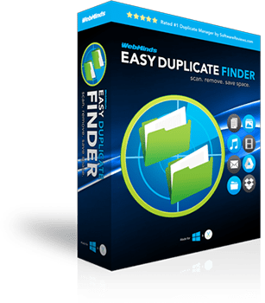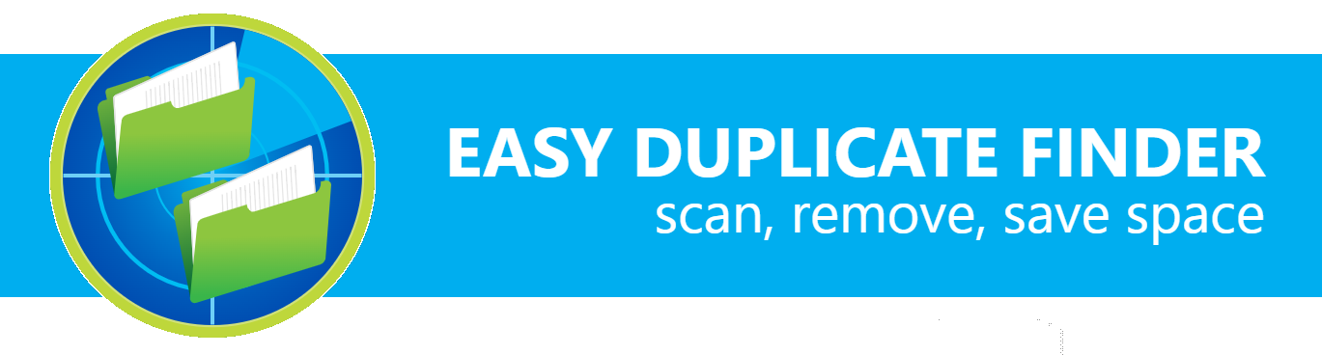

WebMinds, Inc.

Easy Duplicate FinderTM

Version v7.0

User Manual (For Windows Users)

Version 1.0

Jun 24, 2024

Copyright © WebMinds, Inc., 2024

All Rights Reserved

This publication is protected by federal copyright law. No part of this publication may be copied or distributed, stored in a retrieval system, or translated into any human or computer language in any form or by any means, electronic, mechanical, magnetic, manual, or otherwise, or disclosed to third parties without the express written permission of **WebMinds, Inc.**

**WebMinds, Inc.** makes no representation or warranties with respect to the contents hereof and specifically disclaim any implied warranties of merchantability or fitness for a particular purpose. Further, **WebMinds, Inc.** reserves the right to revise this publication and to make changes from time to time in the contents hereof without obligation of **WebMinds, Inc.** to notify any person or organization of such revision or changes.

**WebMinds, Inc.** has prepared this guide for use by **WebMinds, Inc.** personnel and authorized third parties as a guide to proper operation and/or maintenance of **WebMinds, Inc.** equipment and software. The drawings and specifications contained herein are the property of **WebMinds, Inc.**

Trademarked names may appear throughout this user manual. Rather than list the names and entities that own the trademarks or insert a trademark symbol with each mention of the trademarked name, the names are used only for editorial purposes and to the benefit of the trademark owner with no intention of infringing upon that trademark.

Address comments and corrections to:

**WebMinds, Inc.**

950 N Collier Blvd. Suite 400

Marco Island FL 34145

USA

Revision History

|  |  |  |  |
| --- | --- | --- | --- |
| Date | Release | Revision DESCRIPTION | MODIFIED BY |
| Jun 13, 2024 | 0.1 | Initial draft | David A. Flynn |
| Jun 24, 2024 | 1.0 | First base lined user manual | David A. Flynn |
|  |  |  |  |
|  |  |  |  |
|  |  |  |  |
|  |  |  |  |

About this User Manual

This user manual contains information about all the features & functionalities of the Easy Duplicate FinderTM application & instructions on how to use them.

Purpose of this User Manual

The purpose of this user manual is to assist the end users of the Easy Duplicate FinderTM application.

In Scope of this User Manual

The scope of this user manual includes the description and usage of the Easy Duplicate FinderTM application.

Out of Scope of this User Manual

The scope of this user manual does not include –

* the detailed installation process of Easy Duplicate FinderTM application
* the usage of the features and functionalities of your operating system

Intended Audience of this User Manual

The intended audiences of this user manual are –

* end users of the Easy Duplicate FinderTM application

Organization of this User Manual

This user manual contains 13 chapters & 1 appendices as indicated below –

| chapter | Description |
| --- | --- |
| **Chapter 1** | Introduction |
| **Chapter 2** | Getting Started |
| **Chapter 3** | Registering your EDF Application Installation |
| **Chapter 4** | Activating your EDF Application Installation |
| **Chapter 5** | Entering a New Key |
| **Chapter 6** | Removing your EDF License Details |
| **Chapter 7** | Performing a Standard Scan |
| **Chapter 8** | Performing a Byte-by-Byte Comparison Scan |
| **Chapter 9** | Performing a Folder Comparison |
| **Chapter 10** | Performing a Picasa Scan |
| **Chapter 11** | Performing a Lightroom Classic Scan |
| **Chapter 12** | Performing a PaintShop Pro Scan |
| **Chapter 13** | Performing a Fragment Search |
| **Appendix A** | Frequently Asked Questions |

Typographical Conventions / Customaries used in this User Manual

The typographical conventions used in this user manual include the following –

* **Note:** The purpose of this typographical convention is to provide important information corresponding to an already stated fact. This is how we depict a note in this user manual –

**Note:**<Note Text><Note Text><Note Text><Note Text><Note Text><Note Text><Note Text><Note Text><Note Text><Note Text><Note Text><Note Text><Note Text><Note Text>

* **Tip:** The purpose of this typographical convention is to provide additional information supplementing an already stated fact. This is how we depict a tip in this user manual –

**Tip:**<Tip Text><Tip Text><Tip Text><Tip Text><Tip Text><Tip Text><Tip Text><Tip Text><Tip Text><Tip Text><Tip Text><Tip Text><Tip Text><Tip Text><Tip Text><Tip Text><Tip Text>

* **Warning:** The purpose of this typographical convention is to provide critical information corresponding to an already stated fact. This is how we depict a warning in this user manual –

**Warning:**<Warning Text><Warning Text><Warning Text><Warning Text><Warning Text><Warning Text><Warning Text><Warning Text><Warning Text><Warning Text><Warning Text>

* **Reference:** The purpose of this typographical convention is to refer you to another section in this user manual or another document or to an external reference. A reference is depicted in the following manner in this user manual –

**Reference:** To read detailed steps, navigate to **<Chapter Name>** chapter by clicking this link.

or

**Reference:** For more information, navigate to **<Chapter Name>** chapter by clicking this link.

Abbreviations / Acronyms used in this User Manual

The table below describes the abbreviations / acronyms used in this user manual –

|  |  |
| --- | --- |
| Abbreviation | Description |
| **GUI, UI** | Graphical User Interface, User Interface |
| **IPR** | Intellectual Property Rights |
| **EDF** | Easy Duplicate Finder |
| **TM** | Trade Mark |
| **TOC, TOT, TOF** | Table of Contents, Table of Tables, Table of Figures |
| **PC** | Personal Computer |
| **FAQs** | Frequently Asked Questions |
| **CSV** | Comma Separated Values |
| **XMP** | Extensible Metadata Platform |

Terms Used in this User Manual

The below table briefly describes the terms utilized in this user manual –

| chapter | Description |
| --- | --- |
| **End User** | An operator or user of the Easy Duplicate Finder TM application. |

**Table of Contents**

Revision History ii

About this User Manual iii

Purpose of this User Manual iii

In Scope of this User Manual iii

Out of Scope of this User Manual iii

Intended Audience of this User Manual iii

Organization of this User Manual iii

Typographical Conventions / Customaries used in this User Manual iv

Abbreviations / Acronyms used in this User Manual v

Terms Used in this User Manual v

Chapter - 1. Introduction 11

1.1 Downloading the EDF Application Installer 11

Chapter - 2. Getting Started 12

2.1 The Main Screen Description 13

2.2 The Hamburger Menu Options Descriptions 14

2.2.1 The Settings Panel Detailed Description 16

2.2.2 The SHA256 Calculator Detailed Description 28

2.2.3 The Windows DriverStore Cleaner Detailed Description 29

2.2.4 The File/Folder Synchronization Detailed Description 30

2.2.5 The Update Option Detailed Description 31

2.2.6 The About Option Detailed Description 31

2.2.7 The Register Now Option Detailed Description 32

2.2.8 The Clear File Information Cache Detailed Description 32

2.2.9 The Open Wizard Option Detailed Description 33

2.3 Limitations of Utilizing an Unregistered EDF Application in Trial Mode 34

2.4 Performing General Functions during all Scan Types 35

2.4.1 Saving a Scan 35

2.4.2 Importing a Scan 37

2.4.3 Using the Assistant on the Scan Summary Page 38

2.4.4 Scan Detail Page Actions Menu Descriptions 39

Chapter - 3. Getting the Premium Free Trial 59

3.1 Via the Free Trial buttons or link 59

3.2 Via the Register Now Button in the EDF Application Menu 61

Chapter - 4. Purchasing your License Key 64

Chapter - 5. Activating your EDF Installation 65

5.1 Via the Activate buttons or link 65

5.2 Via the Register Now Button in the EDF Application Menu 67

Chapter - 6. Entering a New Key 70

Chapter - 7. Removing your EDF License Details 73

Chapter - 8. Performing a SHA256 Checksum + FileSize Scan 76

Chapter - 9. Performing a Byte-By-Byte Comparison Scan 82

Chapter - 10. Performing a Filename Only Scan 89

Chapter - 11. Performing a Music Scan 96

Chapter - 12. Performing an Outlook Mail Scan 103

Chapter - 13. Performing a Folder Comparison Scan 110

Chapter - 14. Performing a Google Drive Scan 117

Chapter - 15. Performing a Dropbox Scan 124

Chapter - 16. Performing an Empty Folders Scan 131

Chapter - 17. Performing a OneDrive Scan 138

Appendix - A. Frequently Asked Questions (FAQs) 146

Index 162

**Table of Figures**

Figure 1 – Downloading the Easy Duplicate FinderTM application installer executable file 11

Figure 2 – Easy Duplicate FinderTM default screen 12

Figure 3 – Easy Duplicate FinderTM main screen 13

Figure 4 – The EDF application main screen 14

Figure 5 – Easy Duplicate FinderTM settings panel – the General tab 16

Figure 6 – Easy Duplicate FinderTM settings panel – the Scan Settings tab 18

Figure 7 – Easy Duplicate FinderTM settings panel – the Music Scan tab 21

Figure 8 – Easy Duplicate FinderTM settings panel – the Email Scan tab 22

Figure 9 – Easy Duplicate FinderTM settings panel – the Logging tab 24

Figure 10 – Easy Duplicate FinderTM settings panel – the Ignore List tab 25

Figure 11 – Easy Duplicate FinderTM settings panel – the Sounds tab 26

Figure 12 – Easy Duplicate FinderTM settings panel – the Support tab 27

Figure 13 – Easy Duplicate FinderTM SHA256 Calculator 28

Figure 14 – Easy Duplicate FinderTM Windows DriverStore Cleaner 29

Figure 15 – Easy Duplicate FinderTM Windows DriverStore Cleaner 30

Figure 16 – Easy Duplicate FinderTM Updates popup 31

Figure 17 – Easy Duplicate FinderTM About popup 31

Figure 18 – Easy Duplicate FinderTM Clear Information Cache dialog box 32

Figure 19 – Easy Duplicate FinderTM wizard popup – step 1 33

Figure 20 – Easy Duplicate FinderTM wizard popup – step 2 33

Figure 21 – Easy Duplicate FinderTM wizard popup – step 3 34

Figure 22: Scan Summary page 35

Figure 23: Scan Results page 36

Figure 24 – EDF application main screen – Importing a saved scan 37

Figure 25 – Assistant – Step 1 38

Figure 26 – Assistant – Step 2 38

Figure 27 – Scan Details Page Action buttons 39

Figure 28 – Scan Details Page -Preview button 40

Figure 29 – Search / Filter duplicates popup 41

Figure 30: Multiple selection types available for scan results 42

Figure 31: Actions button – Moving selected files to a specific folder 44

Figure 32: Actions button – Replacing selected files with symbolic links 45

Figure 33: Actions button – Replacing selected files with NTFS hard links 46

Figure 34: Actions button – Renaming selected files 47

Figure 35: Actions button – Deleting selected files 48

Figure 36: Actions button – Exporting selected files 49

Figure 41: Actions button – Saving your scan 54

Figure 42: Actions button – Clearing results 55

Figure 43: Actions button – Clearing results 56

Figure 44: Actions button – Undo 57

Figure 45 – Easy Duplicate FinderTM default screen 59

Figure 46 – Specifying your registration details 60

Figure 47 – Easy Duplicate FinderTM default screen 61

Figure 48 – The EDF application main screen 62

Figure 49 – Specifying your registration details 63

Figure 50 – Purchasing your License key – step 1 64

Figure 51 – Purchasing your License Key – step 2 64

Figure 52 – Easy Duplicate FinderTM default screen 65

Figure 53 – Specifying your registration details 66

Figure 54 – Easy Duplicate FinderTM default screen 67

Figure 55 – The EDF application main screen 68

Figure 56 – Specifying your registration details 69

Figure 57 – EDF application main screen 70

Figure 58 – Removing EDF application license key details – About popup 71

Figure 59 – Activating EDF application – step 2 71

Figure 60 – EDF application license key activation successful 72

Figure 61 – EDF application main screen 73

Figure 62 – Removing EDF application license key details – About popup 74

Figure 63 – Removing license key details confirmation popup 74

Figure 64 – Successful Removal of EDF application license key details 75

Figure 65 – Performing a SHA256 Checksum + FileSize Scan – EDF main screen 76

Figure 66 – Selecting one or more folders 78

Figure 67 – Scan results summary page 79

Figure 68 – Scan results details page 80

Figure 69 – Scan Details Page Actions Menu 81

Figure 70 – Performing a Byte-by-Byte Comparison Scan – EDF main screen 82

Figure 71 – Performing a Byte-by-Byte Comparison Scan – EDF main screen 83

Figure 72 – Selecting one or more folders 85

Figure 73 – Scan results summary page 86

Figure 74 – Scan results details page 87

Figure 75 – Scan Details Page Actions Menu 88

Figure 76 – Performing a Filename Only Scan – EDF main screen 89

Figure 77 – Performing a Filename Only Scan – EDF main screen 90

Figure 78 – Selecting one or more folders 92

Figure 79 – Scan results summary page 93

Figure 80 – Scan results details page 94

Figure 81 – Scan Details Page Actions Menu 95

Figure 82 – Performing a Music Scan – EDF main screen 96

Figure 83 – Performing a Music Scan – EDF main screen 97

Figure 84 – Selecting one or more folders 99

Figure 85 – Scan results summary page 100

Figure 86 – Scan results details page 101

Figure 87 – Scan Details Page Actions Menu 102

Figure 88 – Performing a Byte-by-Byte Comparison Scan – EDF main screen 103

Figure 89 – Performing a Byte-by-Byte Comparison Scan – EDF main screen 104

Figure 90 – Selecting one or more folders 106

Figure 91 – Scan results summary page 107

Figure 92 – Scan results details page 108

Figure 93 – Scan Details Page Actions Menu 109

Figure 94 – Performing a Folder Comparison Scan – EDF main screen 110

Figure 95 – Performing a Folder Comparison Scan – EDF main screen 111

Figure 96 – Selecting one or more folders 113

Figure 97 – Scan results summary page 114

Figure 98 – Scan results details page 115

Figure 99 – Scan Details Page Actions Menu 116

Figure 100 – Performing a Google Drive Scan – EDF main screen 117

Figure 101 – Performing a Google Drive Scan – EDF main screen 118

Figure 102 – Selecting one or more folders 120

Figure 103 – Scan results summary page 121

Figure 104 – Scan results details page 122

Figure 105 – Scan Details Page Actions Menu 123

Figure 106 – Performing a Dropbox Scan – EDF main screen 124

Figure 107 – Performing a Dropbox Scan – EDF main screen 125

Figure 108 – Selecting one or more folders 127

Figure 109 – Scan results summary page 128

Figure 110 – Scan results details page 129

Figure 111 – Scan Details Page Actions Menu 130

Figure 112 – Performing a Empty Folders Scan – EDF main screen 131

Figure 113 – Performing a Empty Folders Scan – EDF main screen 132

Figure 114 – Selecting one or more folders 134

Figure 115 – Scan results summary page 135

Figure 116 – Scan results details page 136

Figure 117 – Scan Details Page Actions Menu 137

Figure 118 – Performing a OneDrive Scan – EDF main screen 138

Figure 119 – Performing a OneDrive Scan – EDF main screen 139

Figure 120 – Selecting one or more folders 142

Figure 121 – Scan results summary page 143

Figure 122 – Scan results details page 144

Figure 123 – Scan Details Page Actions Menu 145

Figure 124: Opening the Search / Filter window 155

Figure 125: Search / Filter window 155

Figure 126: Pausing a scan 158

# Introduction

With the advent of digital communication via hand-held devices and email communication, every one of us face challenge of organizing our data files, photos, emails, videos, documents, etc. Even though, in the world of today storage space is cheap, it still requires some amount of maintenance and house-keeping activities because we always require accessing our data files and documents with the minimum number of clicks. This is where Easy Duplicate FinderTM (EDF) enables you to organize your data & files and free-up valuable space by searching for duplicates so that you can delete them in one go.

## Downloading the EDF Application Installer

You can download the Easy Duplicate Finder TM application from the **Download** link available in the menu on the Easy Duplicate Finder TM homepage as depicted in the figure below –

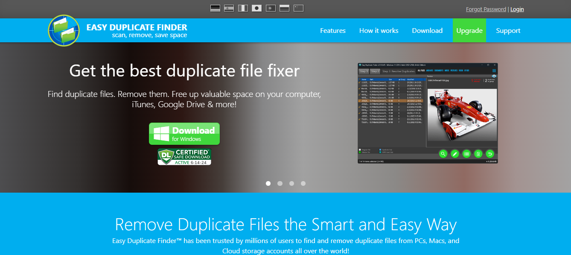

Figure – Downloading the Easy Duplicate FinderTM application installer executable file

**Tip:** After you click the above-mentioned links, you may be warned by your web-browser about a potential security risk due to the downloaded executable file. Please authorize this file.

You can follow the installation wizard by launching the downloaded Easy Duplicate Finder TM installer executable file to install the Easy Duplicate Finder TM application on your system.

**Tip:** After you open the downloaded executable file, you may be warned by your operating system before you can install this application on your system. Please authorize your operating system to continue installing this application at this step.

The next chapter gets you started with the Easy Duplicate Finder TM application that you just installed.

# Getting Started

Double click on the desktop icon of Easy Duplicate FinderTM application. Your EDF application will be launched as depicted in the figure below –

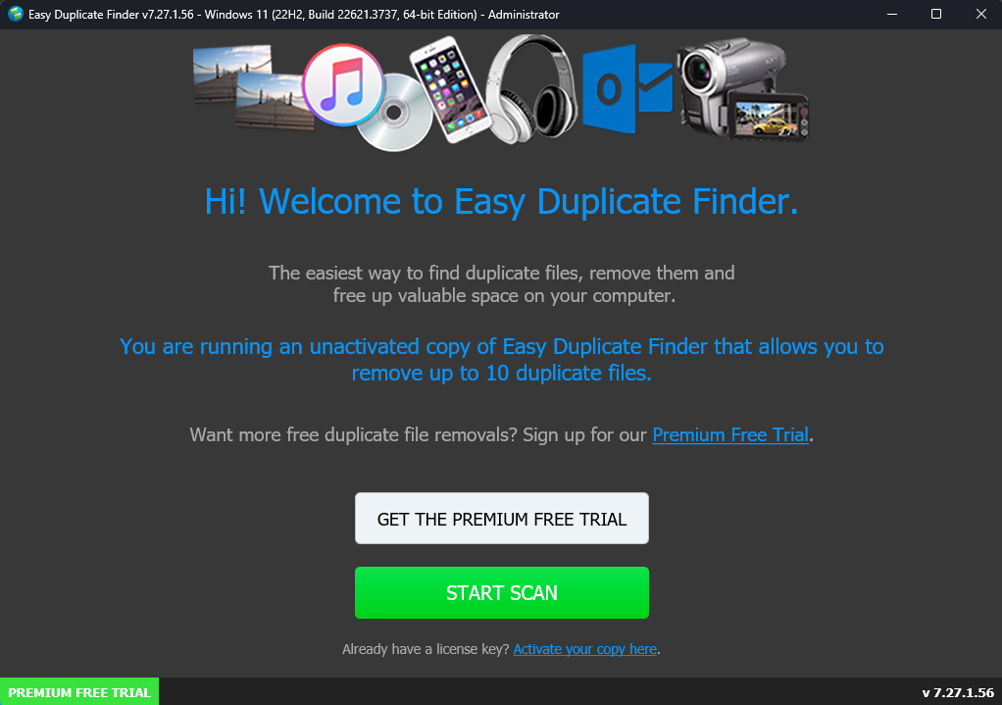

Figure – Easy Duplicate FinderTM default screen

**Tip:** Click the **Premium Free Trial** (any of 2 buttons or the provided link) as depicted in the figure above to get the premium free trial of the Easy Duplicate FinderTM application.

**Reference:** For more information on next steps, refer to the **Getting the Premium Free Trial** chapter.

**Tip:** Click the **Activate your copy here** link under the **Start Scan** button as depicted in the figure above to activate your installation of the Easy Duplicate FinderTM application.

**Reference:** For more information, refer to the **Purchasing your License Key** chapter.

**Tip:** Click the **Start Scan** button to navigate to the main screen of the Easy Duplicate FinderTM application. This screen gets you started with performing your required duplicate scan.

**Reference:** For more information, refer to **The Main Screen** section.

## The Main Screen Description

After you have clicked the **Start Scan** button on the Easy Duplicate FinderTM application default screen, the main screen of the EDF application is displayed as depicted in the figure below –

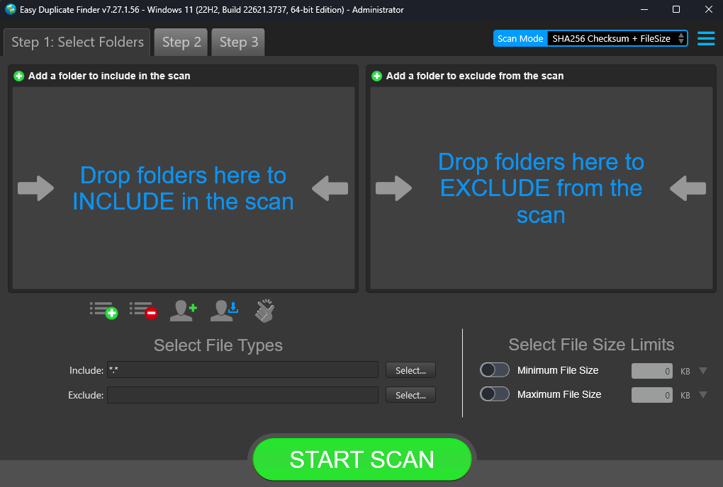

Figure – Easy Duplicate FinderTM main screen

Below is a description of the screen elements of the default screen of the Easy Duplicate FinderTM application.

| **NO.** | | **DESCRIPTION** |
| --- | --- | --- |
| **1** | | Clicking this scan type drop-down list enables you to specify the scan type you intend to perform. Chapters 8 to Chapter 17 describe each scan type in detail. |
| **2** | | These are the 3 step tab header buttons which enable you to perform duplicate file scans easily. The 3 steps are outlined as follows –   * **Step 1 –** This step enables you to select folders required for the selected scan & specify your chosen filter criteria as described in point 4 in this table. * **Step 2 –** This step enables you to start your selected scan and review the results. * **Step 3 –** This step enables you to resolve identified duplicates after you perform a manual review. |
| **3** | | Clicking this button opens the Hamburger menu of EDF application.  **Tip:** For a detailed description of the Settings panel, refer to **The Hamburger Menu Options Descriptions** section. |
| **4** | This area enables you to specify the filter criteria as per your requirements for the selected scan type. | |
| **5** | Click the **Start Scan** button starts your scan. | |

## The Hamburger Menu Options Descriptions

From the main screen of the EDF Application, click the Hamburger menu button on the top right-hand corner of the screen.

**Tip:** To reach the main screen, you may require clicking the **Start Scan** button on the EDF application default screen in case you have not activated your installation yet.

The hamburger menu is displayed as depicted in the figure below –

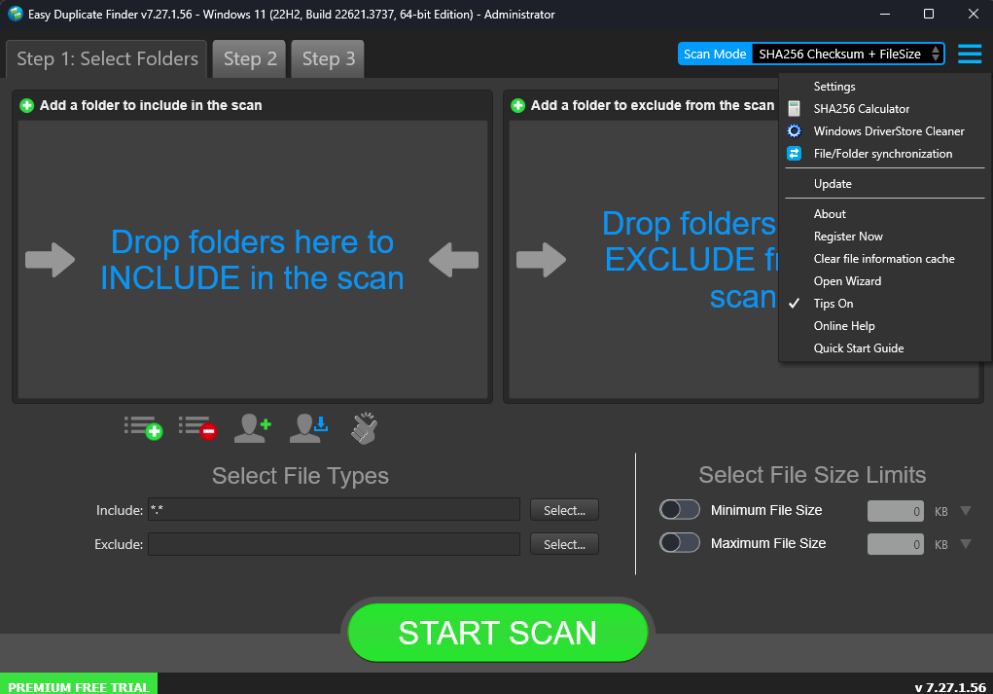

Figure – The EDF application main screen

Below is a description of the options available on the hamburger menu of the Easy Duplicate FinderTM application.

| **OPTION** | **DESCRIPTION** |
| --- | --- |
| **Settings** | Clicking this option opens the Settings panel.  **Reference:** For more information, refer to **The Settings Panel Detailed Description** section. |
| **SHA256 Calculator** | Clicking this option opens the SHA256 Calculator popup.  **Reference:** For more information, refer to **The SHA256 Calculator Detailed Description** section. |
| **Windows DriverStore Cleaner** | Clicking this option opens the Windows DriverStore Cleaner popup.  **Reference:** For more information, refer to **The Windows DriverStore Cleaner Detailed Description** section. |
| **File/Folder Synchronization** | Clicking this option opens the File/Folder Synchronization popup.  **Reference:** For more information, refer to **The File/Folder Synchronization Detailed Description** section. |
| **Update** | Clicking this option opens the Update popup.  **Reference:** For more information, refer to **The Update Option Detailed Description** section. |
| **About** | Clicking this option opens the About popup.  **Reference:** For more information, refer to **The About Option Detailed Description** section. |
| **Register Now** | Clicking this option opens the Register Now popup.  **Reference:** For more information, refer to **The Register Now Option Detailed Description** section. |
| **Clear File Information Cache** | Clicking this option opens the Clear File Information Cache popup window.  **Reference:** For more information, refer to **The Clear File Information Cache Detailed Description** section. |
| **Open Wizard** | Clicking this option opens Open Wizard popup.  **Reference:** For more information, refer to **The Open Wizard Option Detailed Description** section. |
| **Tips On** | Clicking this option enables you to toggle between switching Tips on or off. |
| **Online Help** | Clicking this option opens the online help of the EDF application in your default web browser. |
| **Quick Start Guide** | Clicking this option opens the quick start guide of the EDF application in your default web browser. |

### The Settings Panel Detailed Description

This sub-section describes all tabs and the provided parameters on each of these tabs on the Settings panel.

#### The General tab

The parameters available on the General tab are applicable on most of the common settings of the EDF application. Below are detailed descriptions of the General tab and its parameters as depicted in the figure below –

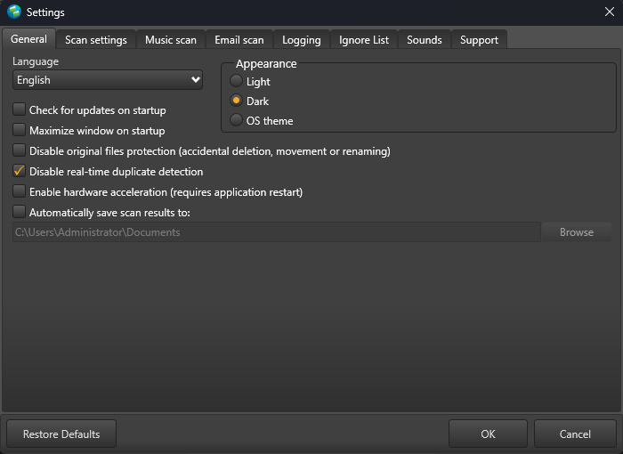

Figure – Easy Duplicate FinderTM settings panel – the General tab

* **Language –** This drop-down list enables you to change the language of you EDF application installation.
* **Appearance –** These mutually inclusive radio buttons enable you to specify which appearance theme is to be applied – i.e., Light, meaning the Windows grey theme, Dark, meaning a black theme, or OS theme, meaning whatever the Windows theme is being used, that will be applied to EDF.
* **Check for updates on startup –** This checkbox enables you to specify if EDF must check for updates when it is starting up
* **Maximize window on startup –** This checkbox enables you to specify if EDF must maximize its window when it is starting up
* **Disable original files protection (accidental deletion, movement or renaming) –** Each group of duplicate files identified in a scan contains the one file. In case files are identical then the shortest filename common in the group of the duplicate files and / or the first file encountered satisfying the afore-mentioned conditions is considered as the original while the rest of the identical files are considered as duplicates. Now if we have selected these files & if we are trying to delete these files, then EDF prevents us from deleting all of them by preserving the best candidate being considered as the original. This is how EDF keeps your files safe & ensures that you never lose them forever due to a selection mistake. In other words, this is how EDF implements protection against accidental deletion of all files in a group of duplicates by default. In case you are sure of what you are doing, then you can select this checkbox to disabled this protection against accidental deletion of all files in a group of duplicates.
* **Disable real-time duplicate detection –** This checkbox enables you to specify if EDF will monitor your computer’s file system in real-time.
* **Enable hardware acceleration (requires application restart) –** This checkbox enables you to specify if EDF will utilize hardware acceleration to perform the specified scans.

**Tip:** You will require restarting the EDF application to enable this feature.

* **Automatically save scan results to: –** All of your scan results are stored in this folder location by default.

**Tip:** Click **Browse** to specify a default folder location of as per your requirements.

* **Restore Defaults –** Clicking this button reverts all settings to the default mode of EDF.
* **OK –** Clicking this button saves the changes made and closes this panel
* **Cancel –** Clicking this button ignores the changes made and closes this panel

#### The Scan Settings tab

The parameters available on the Scan Settings tab enable you to fine tune the scan algorithm to produce better scan results during file comparisons. Below are detailed descriptions of the Scan Settings tab and its parameters as depicted in the figure below –

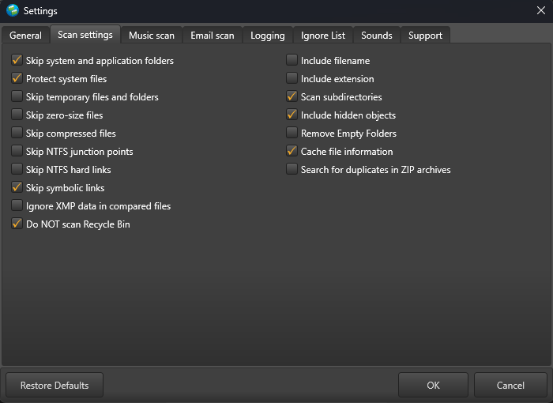

Figure – Easy Duplicate FinderTM settings panel – the Scan Settings tab

* **Skip system and application folders:** This checkbox enables you to specify EDF to skip scanning of system files as well as those within an application folder.
* **Protect system files:** This checkbox enables you to specify EDF to protect removal / deleting of system files.
* **Skip temporary files and folders:** This checkbox enables you to specify EDF to skip scanning of temporary files and folders.
* **Skip zero-size files:** This checkbox enables you to specify EDF to skip scanning of files with 0 bytes file-size.
* **Skip compressed files:** This checkbox enables you to specify EDF to skip scanning of compressed files.
* **Skip NTFS junction points:** This checkbox enables you to specify EDF to skip scanning of NTFS junction points.

**Tip:** Junction Points (also commonly referred to as NTFS Junction or Directory Junction) are a type of reparse point which contains link to a directory that acts as an alias of that directory. Junction point work like a symbolic link but only for directories.

* **Skip NTFS hard links:** This checkbox enables you to specify EDF to skip scanning of NTFS hard links.

**Tip:** In the NTFS file system, a hard link is a file-system representation of a file that allows multiple paths to reference the same file on the same volume. Hard links are essentially mirrored copies of the original file, but they don't duplicate the file's data or require additional hard drive space.

* **Skip symbolic links:** This checkbox enables you to specify EDF to skip scanning of symbolic links.

**Tip:** Symbolic links or symlinks are file system objects that point to another file system object, or target, and are designed to be transparent to users and applications. They appear as normal files or directories and can be used in the same way.

* **Ignore XMP data in compared files:** This checkbox enables you to specify EDF to ignore XMP data of the compared files.

**Tip:** The Extensible Metadata Platform (XMP) is an ISO standard, originally created for the creation, processing, and interchange of standardized and custom metadata for digital documents and data sets. XMP standardizes a data model, a serialization format and core properties for the definition and processing of extensible metadata. It also provides guidelines for embedding XMP information into popular image, video, and document file formats, such as JPEG and PDF, without breaking their readability by applications that do not support XMP.

* **Do NOT scan Recycle Bin:** This checkbox enables you to specify EDF to skip scanning of the Recycle Bin & its contents.
* **Include filename:** This checkbox enables you to specify EDF to perform scanning of the files by including their filename as a parameter which is to be taken into consideration while identifying duplicates.
* **Include extensions:** This checkbox enables you to specify EDF to perform scanning of the files by including their extension as a parameter which is to be taken into consideration while identifying duplicates.
* **Scan subdirectories:** This checkbox enables you to set if sub-directories and their contents are to be check as well or not.
* **Include hidden objects:** This checkbox enables you to specify EDF to include hidden objects in a folder while it identifies duplications.
* **Remove empty folders:** Consider a scenario in which EDF has identified duplicate files and listed them along with their original counterparts. In case a folder containing duplicates is emptied after EDF has removed the duplicate files, selecting this option in the Settings panel instructs EDF to remove the parent empty folder as well.
* **Cache file information:** This checkbox enables you to specify EDF to maintain a cache of the metadata information of scanned files.

**Tip:** Retaining this information in the EDF application cache improves the performance of subsequent scans.

* **Search for duplicates in ZIP archives:** This checkbox enables you to specify EDF to include files within a compressed ZIP archive.

**Tip:** A ZIP archive is a specific format of a compressed file archive which is commonly utilized by Windows platform end users. Therefore, this compressed file archive is more prone to contain duplicates. In case this is selected while the **Skip Compressed Files** checkbox is enabled, then EDF will still include the files within this compressed archive.

* **Restore Defaults –** Clicking this button reverts all settings to the default mode of EDF.
* **OK –** Clicking this button saves the changes made and closes this panel
* **Cancel –** Clicking this button ignores the changes made and closes this panel

#### The Music Scan tab

The parameters on the Music Scan tab enable you to specify whether the music scan is to be done via fingerprint comparison method or via the music tags method. Furthermore, in case the scans are to be done via music tags method then this panel enables you to specify the music tags that are to be taken into consideration while scanning music files.

**Warning:** You can only set these settings in the Music Scan mode. i.e., You must select the Music Scan mode from the Scan Mode drop-down and then click **Settings > Music Scan** to be able to set the parameters on this tab.

Below are detailed descriptions of the Logging tab and its parameters as depicted in the figure below –

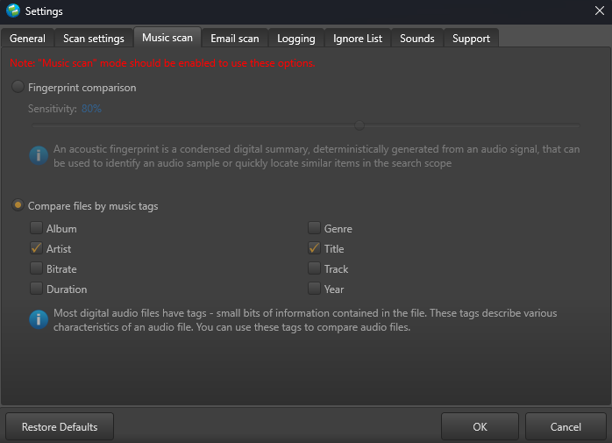

Figure – Easy Duplicate FinderTM settings panel – the Music Scan tab

* **Fingerprint Comparison –** Clicking this radio button sets EDF to perform the Music scan via Fingerprint Comparison method
* **Sensitivity –** This slider enables you to set the sensitivity threshold percentage

**Tip:** Each music file or even a sound signal has an acoustic fingerprint or digital summary or signature (often depicted as a wave form viewed against the timestamp on a frequency graph) which is used to identify an acoustic signal or sample. This parameter enables EDF to test and match the percentage likeness or similarity of the source files with the target files.

* **Compare files by music tags –** This slider enables you to set which of the music tags are to be taken in consideration while performing a music scan

**Tip:** Each music file has small bits of information or metadata embedded within it which enable us to organize our music files. E.g., Artist, Album, Bitrate, Duration, Genre, Title, Track, & Year.

* **Restore Defaults –** Clicking this button reverts all settings to the default mode of EDF.
* **OK –** Clicking this button saves the changes made and closes this panel
* **Cancel –** Clicking this button ignores the changes made and closes this panel

#### The Email Scan tab

The parameters on the Email Scan tab enable you to specify which email comparison options are to be taken into consideration while performing the Email Scan.

**Warning:** You can only set these settings in the Email Scan mode. i.e., You must select the Email Scan mode from the Scan Mode drop-down and then click **Settings > Email Scan** to be able to set the parameters on this tab.

Below are detailed descriptions of the Logging tab and its parameters as depicted in the figure below –

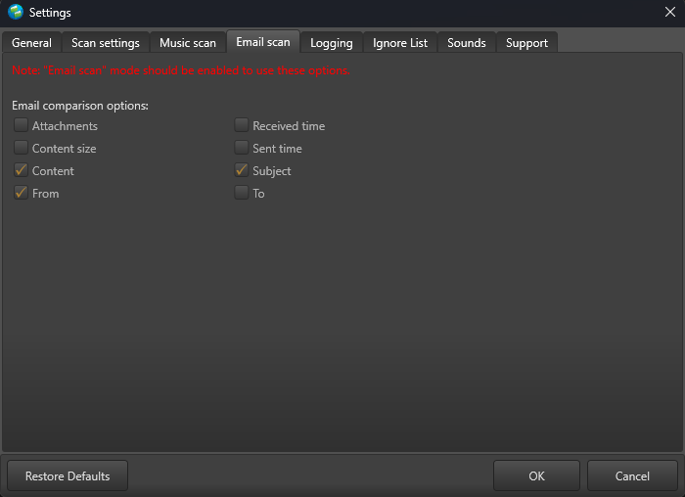

Figure – Easy Duplicate FinderTM settings panel – the Email Scan tab

* **Attachments –** Clicking this checkbox specifies whether attachments of an email are to be considered while performing the email scan.
* **Content size –** Clicking this checkbox specifies whether the content size of an email is to be considered while performing the email scan.
* **Content –** Clicking this checkbox specifies whether the content of an email is to be considered while performing the email scan.
* **From:** Clicking this checkbox specifies whether the From email address of an email are to be considered while performing the email scan.
* **Received time:** Clicking this checkbox specifies whether the Received timestamp or the time at which an email was received is to be considered while performing the email scan.
* **Sent time:** Clicking this checkbox specifies whether the Sent timestamp or the time at which an email was sent is to be considered while performing the email scan.
* **Subject:** Clicking this checkbox specifies whether the Subject of an email is to be considered while performing the email scan.
* **To:** Clicking this checkbox specifies whether the To email address of an email are to be considered while performing the email scan.
* **Restore Defaults –** Clicking this button reverts all settings to the default mode of EDF.
* **OK –** Clicking this button saves the changes made and closes this panel
* **Cancel –** Clicking this button ignores the changes made and closes this panel

#### The Logging tab

The parameters on the Logging tab enable you to specify which events are to be logged and how may days of logs must be to be retained. Below are detailed descriptions of the Logging tab and its parameters as depicted in the figure below –

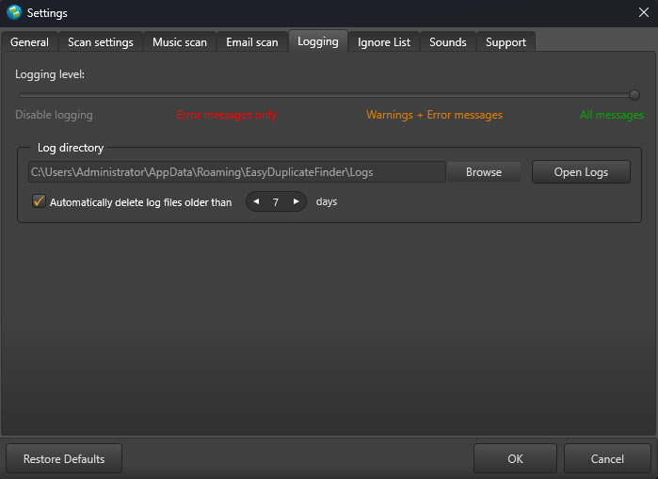

Figure – Easy Duplicate FinderTM settings panel – the Logging tab

* **Logging Level –** This slider enables you to set which types of application messages are to be logged (Disable logging / Error messages only / Warning + Error messages / All messages).
* **Log directory –** This field enables you to specify the path to the folder where all application message logs are to be stored by clicking the **Browse** button and navigating to a folder location as per your requirements.
* **Open Logs –** Clicking this button enables you to view the contents of the logging folder where you can find all the application message logs.
* **Automatically delete log files older than X days:** This input control enables you to specify the number of days (X) for which the log files are to be retained. Files older than this value are discarded automatically for storage space optimization.
* **Restore Defaults –** Clicking this button reverts all settings to the default mode of EDF.
* **OK –** Clicking this button saves the changes made and closes this panel
* **Cancel –** Clicking this button ignores the changes made and closes this panel

#### The Ignore List tab

The parameters on the Ignore List tab enable you to specify which of the files within a folder to be scanned that EDF must ignore while performing the scan operation. As depicted in the figure below this exclusion list overrides any other options set within the EDF application. i.e., EDF application will not allow you to perform a scan, rename any contained file, and move or delete files in the specified folders.

**Warning:** You need to be extremely vigilant before performing a system wide scan. i.e., you must exclude all system folders as depicted in the figure below, before performing a system wide scan. It is not recommended to perform a system wide scan as EDF runs the risk of deleting files being used in the stable functioning of your system.

Below are detailed descriptions of the Ignore List tab and its parameters as depicted in the figure below –

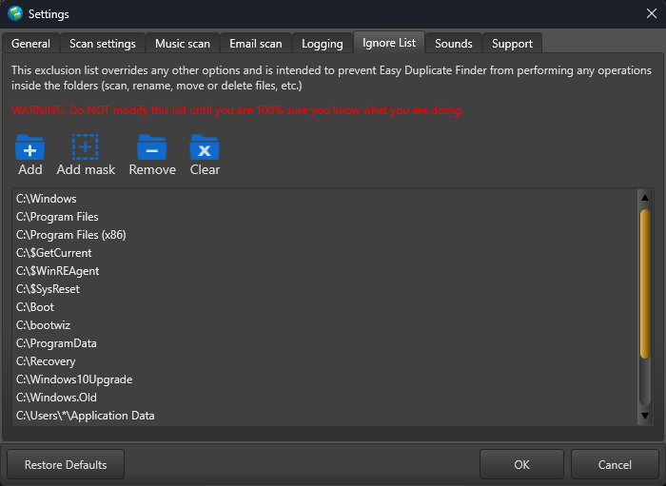

Figure – Easy Duplicate FinderTM settings panel – the Ignore List tab

* **Add –** Clicking this button enables you to add a folder to this ignore list
* **Add Mask –** Clicking this button enables you to add a string as a mask or wildcard entry to the ignore list. While performing a scan, EDF will check for any folder name containing this string and automatically ignore such a folder.
* **Remove –** After selecting a folder from the easel below, clicking this button enables you to remove that folder from this ignore list
* **Clear –** Clicking this button enables you to remove all specified folder in this ignore list
* **Restore Defaults –** Clicking this button reverts all settings to the default mode of EDF.
* **OK –** Clicking this button saves the changes made and closes this panel
* **Cancel –** Clicking this button ignores the changes made and closes this panel

#### The Sounds tab

The parameters on the Sounds tab enable you to specify the mp3 audio files to be played for each of the three events as described in the bulleted list below the figure. Below are detailed descriptions of the Sounds tab and its parameters as depicted in the figure below –

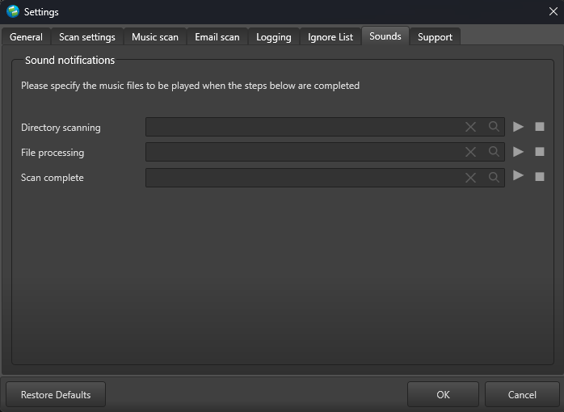

Figure – Easy Duplicate FinderTM settings panel – the Sounds tab

* **Directory scanning –** Clicking the Magnifying glass button enables you to navigate to an mp3 file which you can set for EDF to play when directory scanning is complete. Clicking the triangle Play button enables you to preview the mp3 audio file while the square Stop button stops the file you are previewing to stop playing.
* **File processing –** Clicking the Magnifying glass button enables you to navigate to an mp3 file which you can set for EDF to play when file processing is complete. Clicking the triangle Play button enables you to preview the mp3 audio file while the square Stop button stops the file you are previewing to stop playing.
* **Scan complete –** Clicking the Magnifying glass button enables you to navigate to an mp3 file which you can set for EDF to play when the specified scanning is complete. Clicking the triangle Play button enables you to preview the mp3 audio file while the square Stop button stops the file you are previewing to stop playing.
* **Restore Defaults –** Clicking this button reverts all settings to the default mode of EDF.
* **OK –** Clicking this button saves the changes made and closes this panel
* **Cancel –** Clicking this button ignores the changes made and closes this panel

#### The Support tab

The parameters on the Support tab enable you to prepare application specific detailed data in case your EDF application installation runs into an erroneous event. The Zip archive created when you click the Prepare data button is saved your system’s Documents folder which you can share with our support team. The Support tab is depicted in the figure below –

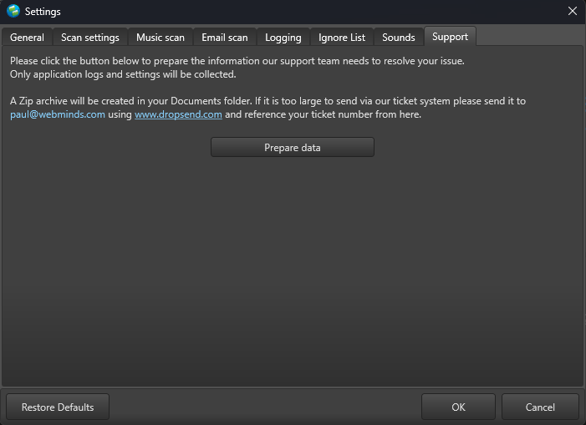

Figure – Easy Duplicate FinderTM settings panel – the Support tab

### The SHA256 Calculator Detailed Description

An SHA256 checksum is a sequence or string of numbers and letters that is calculated using the SHA256 checksum computing algorithm. In other words, this is a digital signature of a file that you intend to compare. Even a small change or a single character variation in a file’s content produces a very different looking checksum. This sub-section describes how you can specify a file, calculate this file’s SHA256 checksum, & then manually compare it with that of another file.

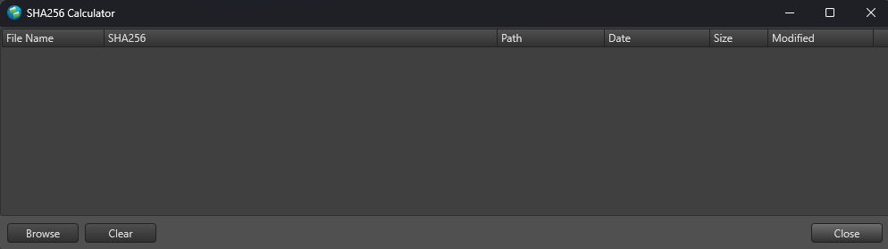

Figure – Easy Duplicate FinderTM SHA256 Calculator

* **Browse –** Clicking this button opens the Open dialog box which you can utilize to select a single file, at a time, for which you intend to calculate the SHA256 checksum

**Tip:** Click the Browse button again to load another file which you intend to compare with the previously opened one.

* **Clear –** Clicking this button clears the easel depicted above
* **Close –** Clicking this button closes this popup

### The Windows DriverStore Cleaner Detailed Description

All hardware resources of your PC are connected to the motherboard of your system via controller hardware embedded in your motherboard. Each of these controllers utilizes critical software called device drivers which enable your motherboard to manage each of these hardware resources. This sub-section describes how you can select a device driver & then delete it from your system.

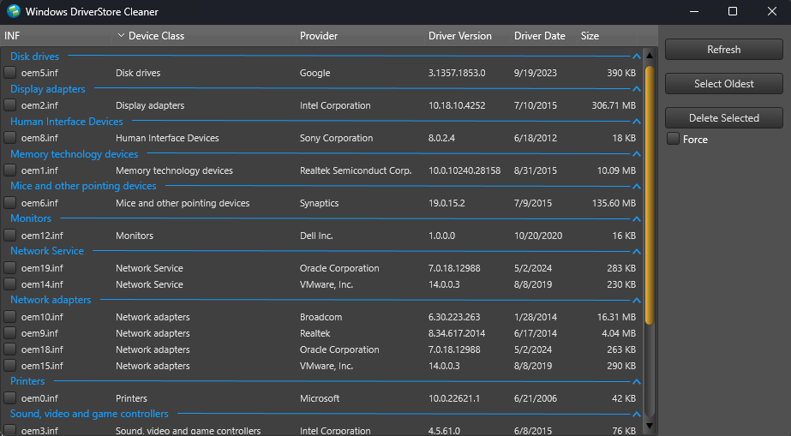

Figure – Easy Duplicate FinderTM Windows DriverStore Cleaner

* **Refresh –** Clicking this button refreshes the list of device drivers of your Windows DriverStore
* **Select Oldest –** Clicking this button selects the oldest device drivers in your Windows DriverStore
* **Delete Selected –** Clicking this button deletes the selected device drivers in your Windows DriverStore. A confirmation dialog box is displayed which enables you to confirm deleting of the selected oldest device drivers. Click **Yes** to continue or **No** to cancel deleting of the selected device drivers.

**Tip:** Performing this action requires Administration privileges. i.e., you should be logged in via an Administrator user account.

* **Force–** Clicking this checkbox after you have selected device drivers in your Windows DriverStore forces deleting of these device drivers

### The File/Folder Synchronization Detailed Description

This sub-section describes how you perform file/folder synchronization between the specified source and target folders.

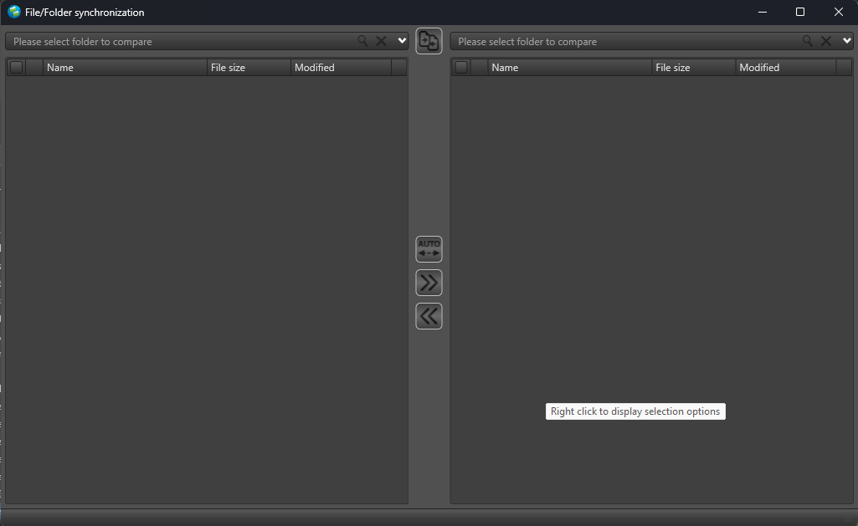

Figure – Easy Duplicate FinderTM Windows DriverStore Cleaner

* **Please select folder to compare –** Clicking this drop down enables you to select the source & target folders. The left drop-down enables you to select the source folder while the right drop down enables you to select the target folder.
* **Compare Left to Right –** Clicking this button after you have selected the source and target folders compares files within these folders
* **Auto –** Clicking this button after selecting the source and target folders opens the Auto-Synchronize menu with the following options and enables you to perform auto-synchronization of files.
  + **Copy newest or the missing files from Left to Right –** Clicking this button copies newest or missing files from the left folder to the right.
  + **Copy newest or the missing files from Right to Left–** Clicking this button copies newest or missing files from the right folder to the left.
* **Copy selected from Left to Right –** Clicking this button copies selected files from the left folder to the right.
* **Copy selected from Right to Left–** Clicking this button copies selected files from the right folder to the left.

### The Update Option Detailed Description

Clicking this button from the Hamburger menu of the EDF application enables you to download and apply application updates to your EDF application installation. In case your EDF installation is up-to-date, then a confirmation is displayed as depicted in the figure below –

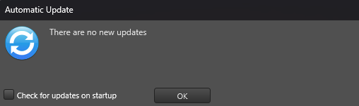

Figure – Easy Duplicate FinderTM Updates popup

**Tip:** Select the **Check for updates on startup** to enable EDF application to check for updates every time it starts up.

Click **OK** to continue.

### The About Option Detailed Description

Clicking this button from the Hamburger menu of the EDF application enables you to open the About popup which displays the license details of your EDF application installation as depicted in the figure below –

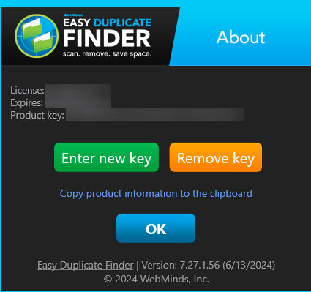

Figure – Easy Duplicate FinderTM About popup

**Reference:** For more information, refer to **Entering a New Key** & **Removing your EDF License Details** chapters.

Click **OK** to continue.

### The Register Now Option Detailed Description

This option is only displayed if you have not registered your EDF application installation.

**Reference:** For more information, refer to the **Via the Register Now Button in the EDF Application Menu** section.

### The Clear File Information Cache Detailed Description

Each time you perform a scan, the meta data of the scanned files is maintained in the file information cache of your EDF application installation. Clicking this option clears the file information cache. A confirmation dialog box is displayed as depicted in the figure below after you click this option –

**Tip:** Clearing your file information cache reduces the performance of subsequent scans

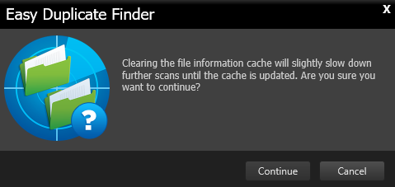

Figure – Easy Duplicate FinderTM Clear Information Cache dialog box

Click **Continue** to continue clearing the file information cache or click **Cancel** to cancel performing this operation.

### The Open Wizard Option Detailed Description

Clicking this option opens the EDF application wizard which enables you to quickly perform a duplicate scan in a short 3 step process as described in this section in detail.

#### Step 1

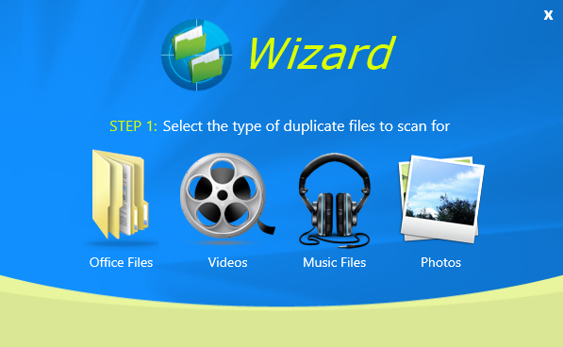

Figure – Easy Duplicate FinderTM wizard popup – step 1

Select the type of files you intend to scan on this step.

#### Step 2

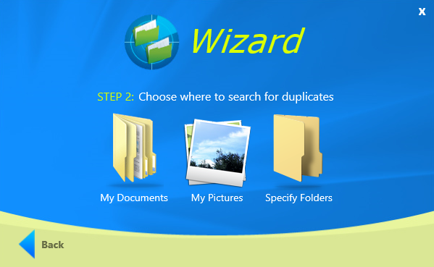

Figure – Easy Duplicate FinderTM wizard popup – step 2

Select the folder location of the files you intend to scan on this step.

**Tip:** To specify multiple specific folders as per your requirements click **Specify Folders**. You can **Add**, **Remove**, or **Clear** the list of specified folders from the subsequent popup which is displayed after you click this option. Click **Back** to go back to the previous step.

#### Step 3



Figure – Easy Duplicate FinderTM wizard popup – step 3

Click **Get Started** to start performing the duplicate scan as per your specified criteria.

**Tip:** Click **Start Over** to clear the specifications you made in the previous steps and restart this wizard from step 1.

Once the scan is complete, the Scan Summary page is displayed which you can utilize to manually review the identified duplicates by clicking the **Manual Review** button or automatically remove the duplicates by clicking the **Auto Remove** buttons.

## Limitations of Utilizing an Unregistered EDF Application in Trial Mode

The trial version of Easy Duplicate FinderTM offers unlimited scanning for duplicates. You can then delete up to 10 duplicate groups with the trial version.

Therefore, it makes more sense to purchase a license package as per your usage requirements and specific use case scenario.

**Tip:** However, if you intend to scan more duplicates, you can get the premium free trial to add 20 more duplicate groups to your account.

**Reference:** For more information, refer to the **Getting the Premium Free Trial** chapter.

## Performing General Functions during all Scan Types

The EDF application provides additional general functions that you can perform on the results list which are common to all scan types. The following sub-sections describe steps that enable to utilize these additional general functions.

### Saving a Scan

After you have performed any type of scan, you can perform the Save Scan function in below ways –

* **Saving a scan from the Scan Summary page**
* **Saving a scan from the Scan Details page**

**Reference:** Click the links provided above to navigate to the corresponding sub-sections.

#### Saving a scan from the Scan Summary page

After you have performed any type of scan, the Scan summary page is displayed as depicted in the figure below –

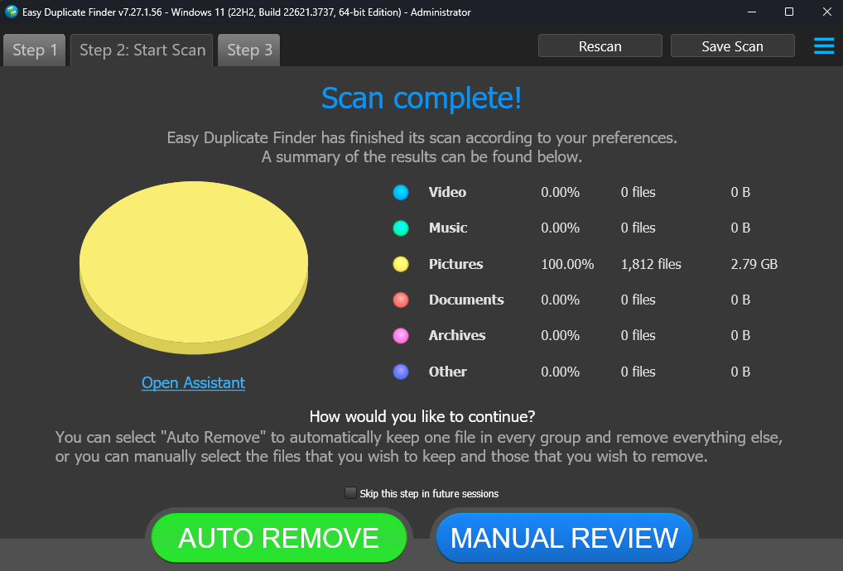

Figure : Scan Summary page

Click the **Save Scan** button as depicted in the figure above The **Save As** dialog box is displayed which enables you to save this scan as a **.edfscan** file at the folder location of your choice.

#### Saving a scan from the Scan Details page

After you have performed any type of scan, the Scan Summary page is displayed as depicted in the previous section. Click the **Manual Review** button to reach the Scan Details page is displayed as depicted in the figure below –

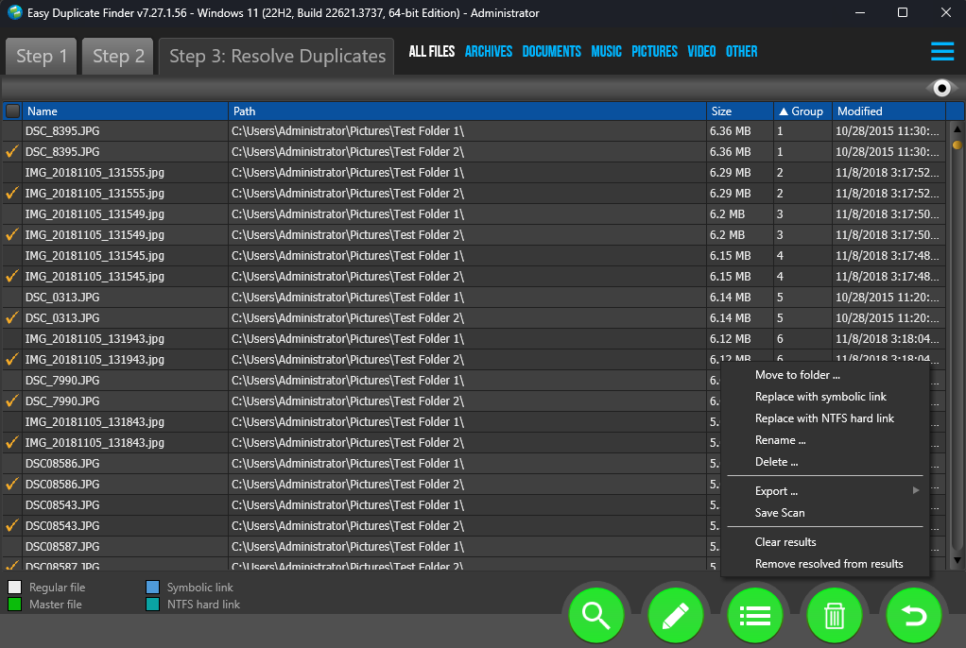

Figure : Scan Results page

Click the **Actions** button as depicted in the figure above to open the actions menu and click **Save Scan**. The **Save As** dialog box is displayed which enables you to save this scan as a **.edfscan** file at the folder location of your choice.

### Importing a Scan

From the main screen of the EDF application, after you have selected the required scan mode from the corresponding drop down as indicated below on the top right-hand corner of the screen. Click the **Import** button as indicated below. The **Import** menu is opened as depicted in the figure below –

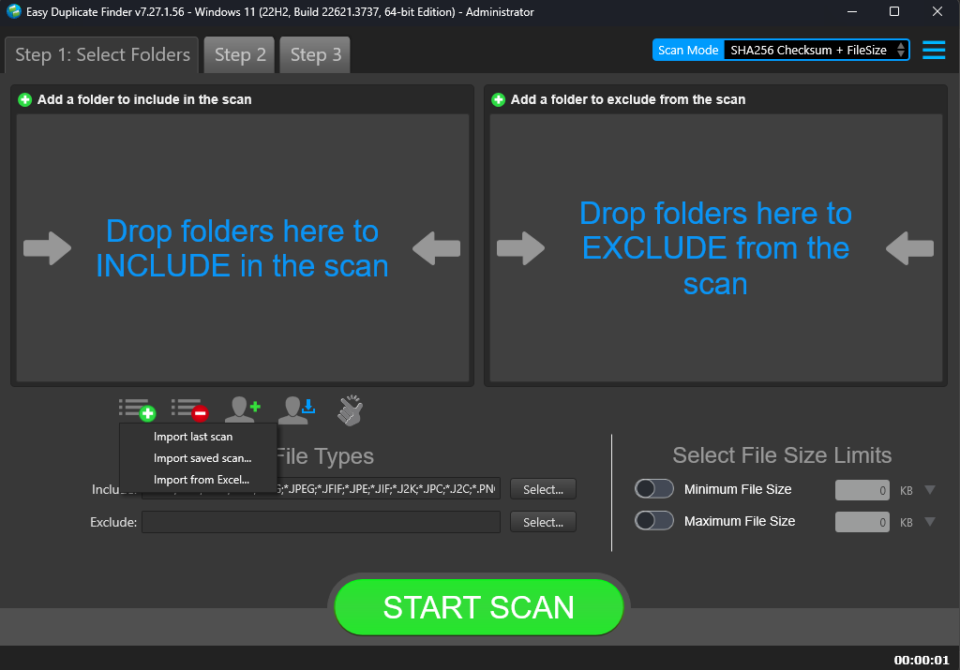

Figure – EDF application main screen – Importing a saved scan

* **Import last scan –** Clickingthis option enables you to import the last scan that you performed.

**Tip:** To utilize this option, you must enable **Automatically save scan results to:** checkbox from the General tab on the Settings panel. In case this option is not selected & you click this option, the a **Nothing to import. . .**  message is displayed with the cautionary note to switch on the corresponding setting as describe above.

* **Import last saved scan –** Clickingthis option enables you to import the last saved scan.
* **Import from Excel –** Clickingthis option enables you to import a saved scan from an Excel file which you exported previously using the Export option from the Actions menu.

### Using the Assistant on the Scan Summary Page

While performing any type of scan, you can utilize the Assistant to quickly select Newest, Oldest, or Originals and then Remove, Rename, or Move duplicates as described in this section.

The steps described below enable you utilize the Assistant wizard as depicted in the figure below –

1. Click **Open Assistant** on the Scan Summary page. The Assistant wizard is displayed as depicted in the figure below –

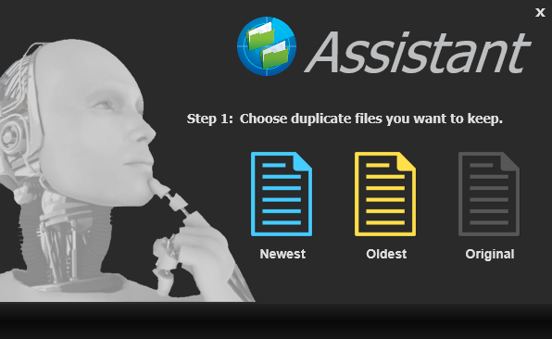

Figure – Assistant – Step 1

1. Click the **Newest**, **Oldest**, or **Original** button (and not the text). The Step 2 screen is displayed as depicted in the figure below –

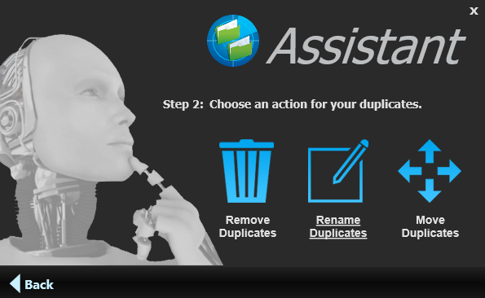

Figure – Assistant – Step 2

1. Click **Remove Duplicates**, **Rename Duplicates**, or **Move Duplicates** (and not the text) as per your requirements.

### Scan Detail Page Actions Menu Descriptions

While performing the 10 types of scans that the Windows based Easy Duplicate FinderTM application performs, this section describes the scan detail page actions menu. This actions menu provides buttons for specific functions that are described in the following sub-sections and depicted in the figure below –



Figure – Scan Details Page Action buttons

| **BUTTON** | **NAME** | **DESCRIPTION** |
| --- | --- | --- |
|  | **Preview** | Clicking this button enables you to view the selected file content preview.  **Tip:** This button is provided on the top right-hand corner of the scan details table under the Hamburger menu button. |
|  | **Search** | Clicking this button enables you to Search the within the original and duplicate files listed on the scan details page.  **Reference:** For a detailed information on this button, refer to **Performing a Search / Filter Duplicates Action** section. |
|  | **Select** | Clicking this button enables you to Move duplicate files as listed on the scan details page to a folder of your choice.  **Reference**: For a detailed information on this button, refer to **Performing Multiple Types of Selections on the Scan Results page** section. |
|  | **Actions** | Clicking this button enables you to replace duplicates with symbolic links or NTFS hard links to the original file as listed on the scan details page.  **Reference**: For a detailed information on this button, refer to Error! Reference source not found. section. |
|  | **Delete** | Clicking this button enables you to Delete selected duplicates as listed on the scan details page.  **Reference**: For a detailed information on this button, refer to **Deleting selected files** section. |
|  | **Undo** | Clicking this button enables you to Undo your previous actions that you perform on the duplicates listed on the scan details page.  **Reference**: For a detailed information on this button, refer to **Performing an Undo Action** section. |

#### Viewing the File Contents Preview

Clicking the **Preview** button on the Scan Details page under the Hamburger menu button opens the Preview pane as depicted in the figure below –

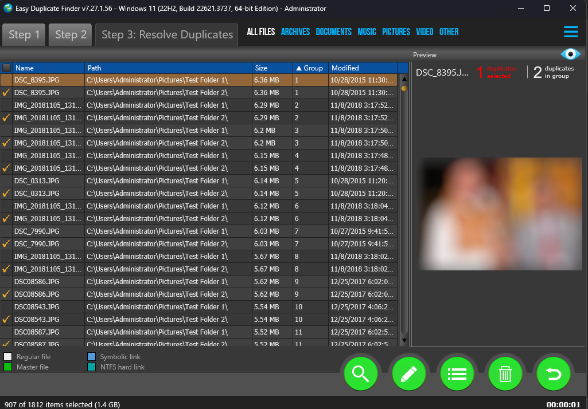

Figure – Scan Details Page -Preview button

#### Viewing Files based on their File Type

You can also view the files displayed on the scan details page by clicking the file type buttons provided on this screen next to the Step 3 tab as indicated below –

* **All files:** Clicking this button displays all the files on this page.
* **Archives:** Clicking this button displays all the compressed archive files on this page.
* **Documents:** Clicking this button displays all the document files on this page.
* **Music:** Clicking this button displays all the music files on this page.
* **Pictures:** Clicking this button displays all the picture files on this page.
* **Video:** Clicking this button displays all the video files on this page.
* **Other:** Clicking this button displays all the other files on this page.

#### Performing a Search / Filter Duplicates Action

Consider a scenario where in you performed a SHA256 Checksum + FileSize Scan, say for example, and then you want to search for duplicates of a specific photo. In this case you can click the Search button from Scan Detail Page Actions Menu on the bottom right-hand corner of the scan details page. The Search / Filter Duplicates popup is displayed as depicted in the figure below –

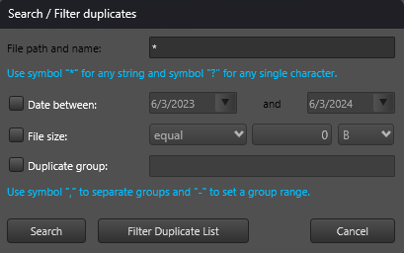

Figure – Search / Filter duplicates popup

Using this popup you can perform the following type of searches –

* **By File path and name:** You can search for duplicates based on the wildcard criteria that you specify here. A wildcard criteria can be specified using a **\*** to denote a string of sequential characters while if you specify **?** then it means that any single character can be replaced by the **?** symbol. E.g., to specify all JPG files, you can specify **\*.jpg** as the search criteria.
* **By Date between:** You can search for duplicates based on the date stamp by specifying the start and end dates of a date range.
* **By File size:** You can search for duplicates based on the file size criteria. i.e., you can specify the file size criteria to search for duplicates by using **equal** operator, **larger than**, or **less than** criteria. The last drop-down enables you to specify whether the file-size being specified is in bytes(B), kilobytes (KB), megabytes (MB), or gigabytes (GB).
* **By Duplicate group:** You can search for duplicates by specifying comma (,) separated values in this field. You can also use the **–** symbol to specify a duplicate group range.
* **Search:** Clicking this button applies the specified filter criteria
* **Filter Duplicate List:** Clicking this button filters the duplicate as per the specified criteria.

**Tip:** The applied filter criteria is displayed at the bottom of the scan details table which you can edit by clicking the **Edit** button provided on the right of this blue strip.

* **Cancel:** Clicking this button cancels application of the specified filter criteria

#### Performing Multiple Types of Selections on the Scan Results page

This sub-section describes all the selection types that you can perform on the scan results that are displayed on the scan details page as depicted in the figure below –

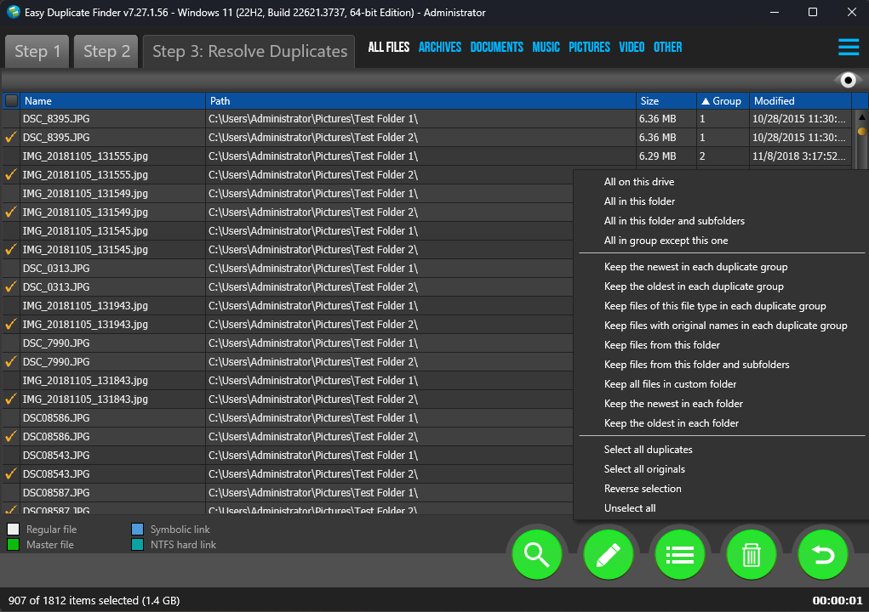

Action button

Figure : Multiple selection types available for scan results

After you have selected a target file on which you intend to apply a selection criterion, you can perform the below tasks –

* **All on this drive –** Clicking this option enables you to select all files on this drive
* **All in this folder –** Clicking this option enables you to select all files in this folder
* **All in this folder and subfolders –** Clicking this option enables you to select all files in this folder and its sub-folders
* **All in group except this one –** Clicking this option enables you to select all other files of this group except the selected file
* **Keep the newest in each duplicate group –** Clicking this option enables you to select & retain the newest file in each duplicate group
* **Keep the oldest in each duplicate group –** Clicking this option enables you to select & retain the oldest file in each duplicate group
* **Keep the file of this type in each duplicate group –** Clicking this option enables you to select & retain the files of the selected file type in each duplicate group
* **Keep files with original names in each duplicate group –** Clicking this option enables you to select & retain files with original names in each duplicate group
* **Keep files from this folder –** Clicking this option enables you to select & retain files from the parent folder of the selected file
* **Keep files from this folder and its subfolders –** Clicking this option enables you to select & retain files from the parent folder of the selected file including those within the sub-folders in this parent folder
* **Keep all files in custom folder –** Clicking this option enables you to specify a custom folder from the **Select Folder** popup displayed onscreen, then specify whether this criterion is to be applied on sub-folders or not using the **Include subfolder** checkbox, and then retain all files in the specified custom folder. Click **Ok** to apply this criterion or click **Cancel** to continue.
* **Keep the newest in each folder –** Clicking this option enables you to select the newest file in each folder listed on this page
* **Keep the oldest in each folder –** Clicking this option enables you to select the oldest file in each folder listed on this page
* **Select all duplicates –** Clicking this option enables you to select all duplicate files in this list
* **Select all originals –** Clicking this option enables you to select all original files in this list
* **Reverse selection –** Clicking this option enables you to select all other files except the ones that are currently selected. i.e., the currently selected files will be deselected while the other files will be selected.
* **Unselect all –** Clicking this option enables you to unselect all files in this list

#### Moving selected files to a specific folder

This sub-section describes steps that enable you to move selected files to a specific folder as depicted in the figure below –

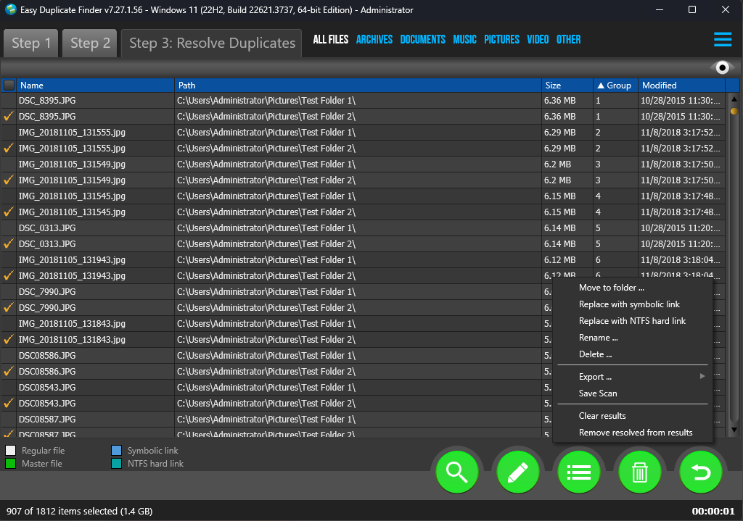

Action button

Figure : Actions button – Moving selected files to a specific folder

Select the duplicate files that you intend to move to a specific folder & click the **Action >** **Move to folder** option. A **Move to folder** popup is displayed which you can utilizes to specify a folder location of your choice.

**Tip:** Selecting the **Keep folder structure** checkbox on this popup retains the folder structure (within the specified folder) of the duplicates that you selected.

Click **Continue** to continue apply this criterion or click **Cancel** to cancel performing this action.

#### Replacing selected files with symlinks

This sub-section describes steps that enable you to replace selected files with symlinks or symbolic links as depicted in the figure below –



Action button

Figure : Actions button – Replacing selected files with symbolic links

**Tip:** Symbolic links or symlinks are file system objects that point to another file system object, or target, and are designed to be transparent to users and applications. They appear as normal files or directories and can be used in the same way.

Select the duplicate files that you intend to replace with their corresponding symlinks & click the **Action > Replace with symbolic link** option. A confirmation dialog box is displayed which enables you to confirm or deny performing this action.

**Warning:** Selecting the **Do not show again** checkbox on this popup will not show this dialog box in such subsequent replace with symlinks operation. Use this option only if you are sure that you do not want to be asked for confirmation at this step in this operation in future.

Click **Yes** to continue apply this operation or click **No** to cancel performing this operation.

#### Replacing selected files with NTFS hard links

This sub-section describes steps that enable you to replace selected files with NTFS hard links as depicted in the figure below –



Action button

Figure : Actions button – Replacing selected files with NTFS hard links

**Tip:** A hard link is a file-system representation of a file that allows multiple paths to reference the same file on the same volume. Hard links are essentially mirrored copies of the original file, but they don't duplicate the file's data and don't require additional hard drive space.

Select the duplicate files that you intend to replace with their corresponding symlinks & click the **Action > Replace with NTFS hard link** option. A confirmation dialog box is displayed which enables you to confirm or deny performing this action.

**Warning:** Selecting the **Do not show again** checkbox on this popup will not show this dialog box in such subsequent replace with symlinks operation. Use this option only if you are sure that you do not want to be asked for confirmation at this step in this operation in future.

Click **Yes** to continue apply this operation or click **No** to cancel performing this operation.

#### Renaming selected files

This sub-section describes steps that enable you to rename selected files as depicted in the figure below –



Action button

Figure : Actions button – Renaming selected files

Select the duplicate files that you intend to rename & click the **Action > Rename** option. A **Rename** popup is displayed which you can utilize to specify a text / string to add, select whether it is to be prefixed or suffixed to the filename.

**Tip:** Selecting the **Rename all as original files** checkbox on this popup marks all files being renamed as originals.

Click **Continue** to continue apply this operation or click **Cancel** to cancel performing this operation.

#### Deleting selected files

This sub-section describes steps that enable you to delete selected files as depicted in the figure below –



Action button

Figure : Actions button – Deleting selected files

Select the duplicate files that you intend to delete & click the **Action > Delete** option. A **Delete** popup is displayed which you can utilize to move these files to the recycle bin or delete them permanently. All deleted files will be displayed in red with a strikethrough once this operation is completed.

**Warning:** Selecting the **Delete permanently** radio button on this popup deletes the files permanently and you cannot undo this operation.

Click **Yes** to continue apply this operation or click **Cancel** to cancel performing this operation.

#### Exporting your Scan Result Details as a File

This sub-section describes all the types of scan result details export that you can perform on the scan results that are displayed on the scan summary page –

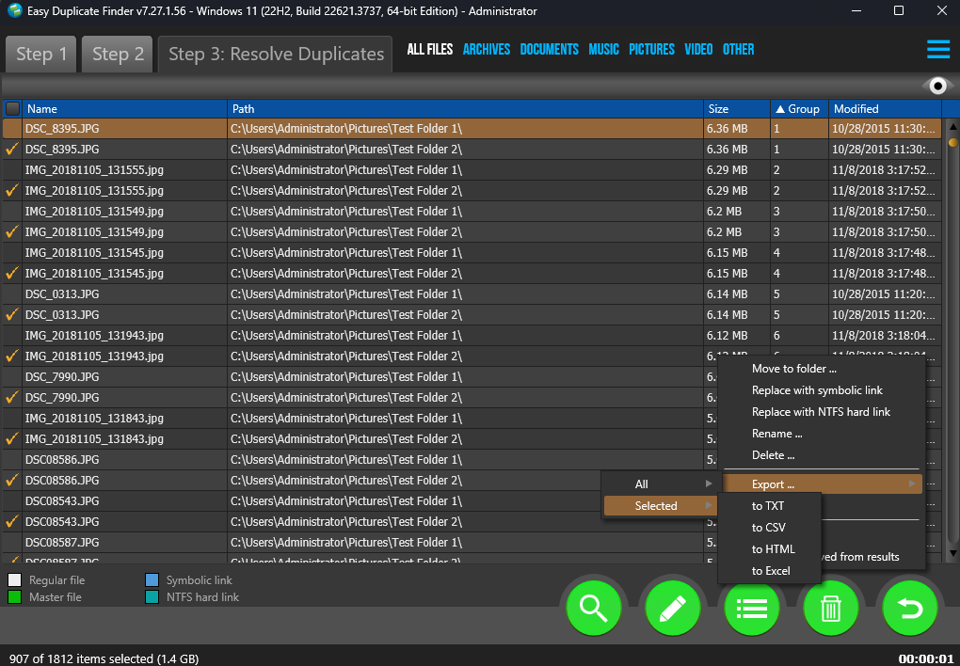

Action button

Figure : Actions button – Exporting selected files

* Select the duplicate files that you intend to export & click the **Action > Export > Selected** option to export selected files.

**Tip:** You can also export all files by clicking the **Action > Export > All** option

Below are the export types that you can select as per your requirements –

* **Export to TXT –** Clicking this option enables you to export selected file details as a text file. Once you have exported the selected file details as a Text file, after opening this file in notepad, the output includes key details of the scan along with a table depicted both original files listed with their duplicates as depicted in the figure below –

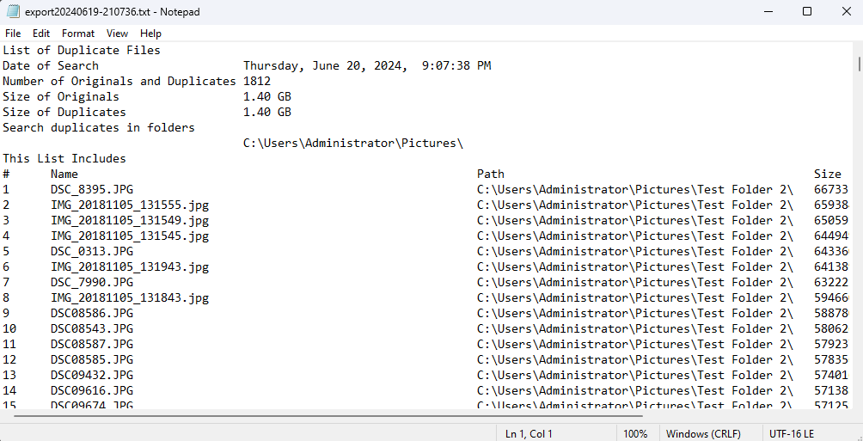

**Figure 37: Scan result details exported as a Text file**

* **Export to CSV –** Clicking this option enables you to export selected file details as a Comma Separated Values (CSV) file. Once you have exported the selected file details as an CSV file, after opening the CSV in your MS Excel application, the output includes key details of the scan along with a table depicted both original files listed with their duplicates as depicted in the figure below –

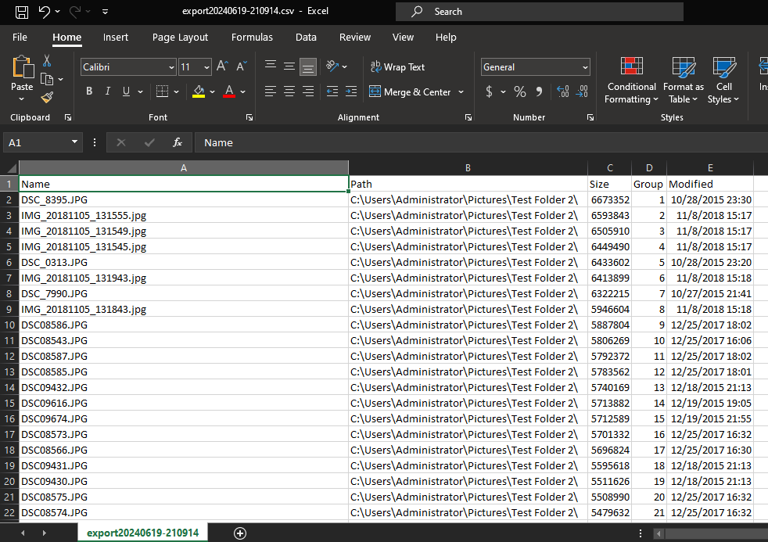

**Figure 38: Scan result details exported as a CSV file**

* **Export to HTML –** Clicking this option enables you to export selected file details as a Hyper Text Markup Language (HTML) file. Once you have exported the selected file details as an HTML file, after opening the HTML file in your default web browser the output includes key details of the scan along with a table depicted both original files listed with their duplicates as depicted in the figure below –

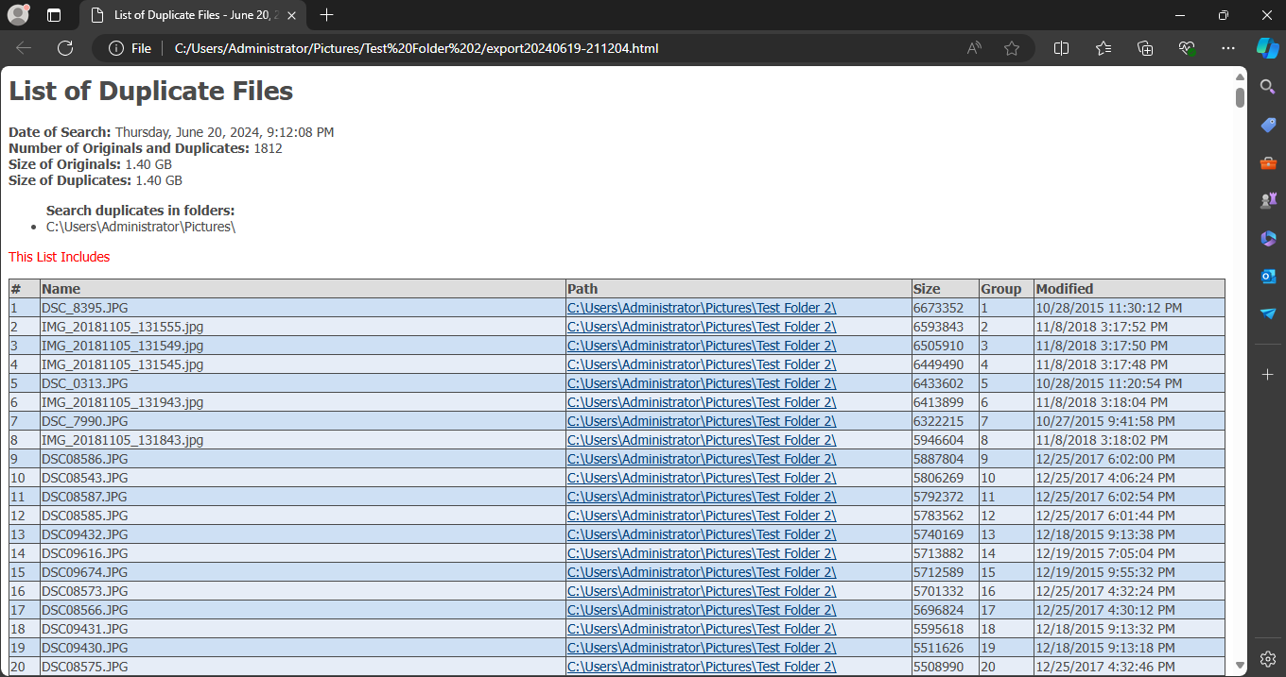

**Figure 39: Scan result details exported as an HTML file**

* **Export to XLS –** Clicking this option enables you to export selected file details as a Microsoft Excel file. Once you have exported the selected file details as an XLS or MS Excel file, after opening this file in MS Excel, the output includes key details of the scan along with a table depicted both original files listed with their duplicates as depicted in the figure below –

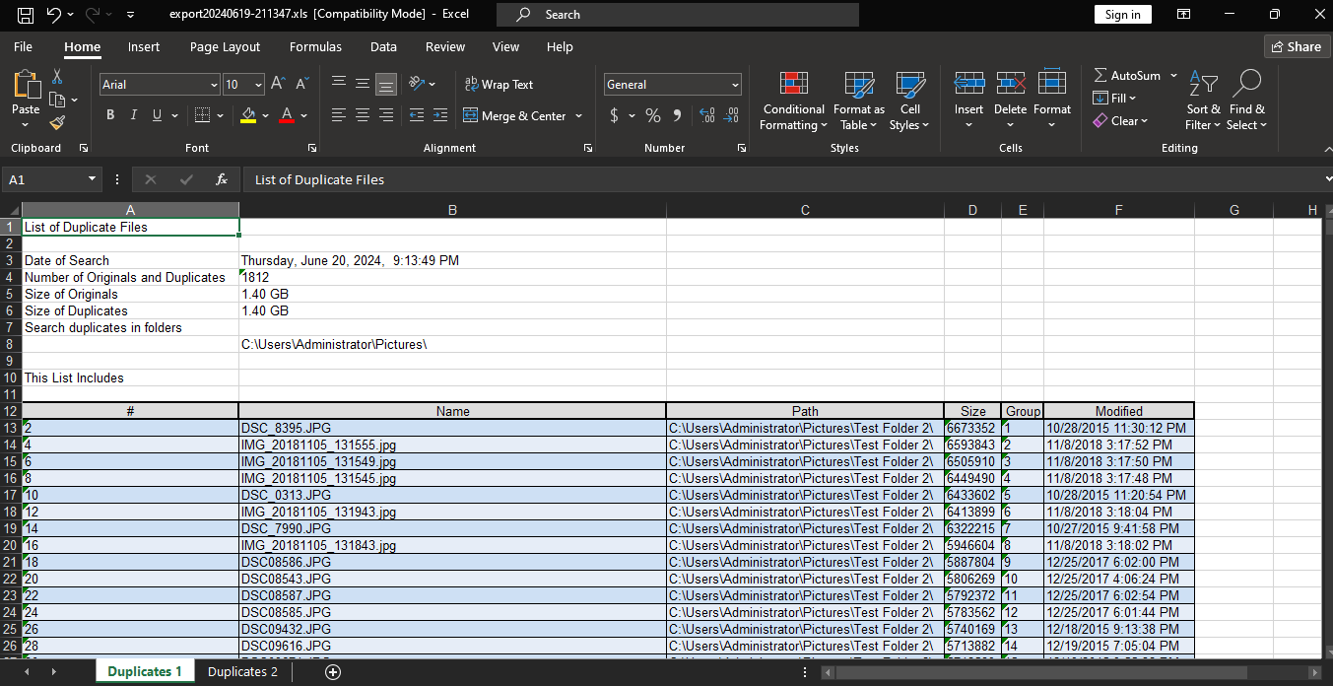

**Figure 40: Scan result details exported as an XLS file**

#### Saving your scan

This sub-section describes steps that enable you to save your scan as depicted in the figure below –



Action button

Figure : Actions button – Saving your scan

After you click the **Save scan** option, a **Saves as** dialog box is displayed which you can utilize to specify a folder location of your choice and save your scan as a **.edfscan** file.

**Reference:** For more information, refer to **Saving a Scan** section.

#### Clearing the Displayed Scan Results from Scan Results page

This sub-section describes steps that enable you to clear the displayed results on the scan details page as depicted in the figure below –



Action button

Figure : Actions button – Clearing results

After you click the **Clear results** option, the displayed results will be cleared on this easel

#### Removing resolved files from the results

This sub-section describes steps that enable you to remove resolved files from the displayed results on the scan details page as depicted in the figure below –

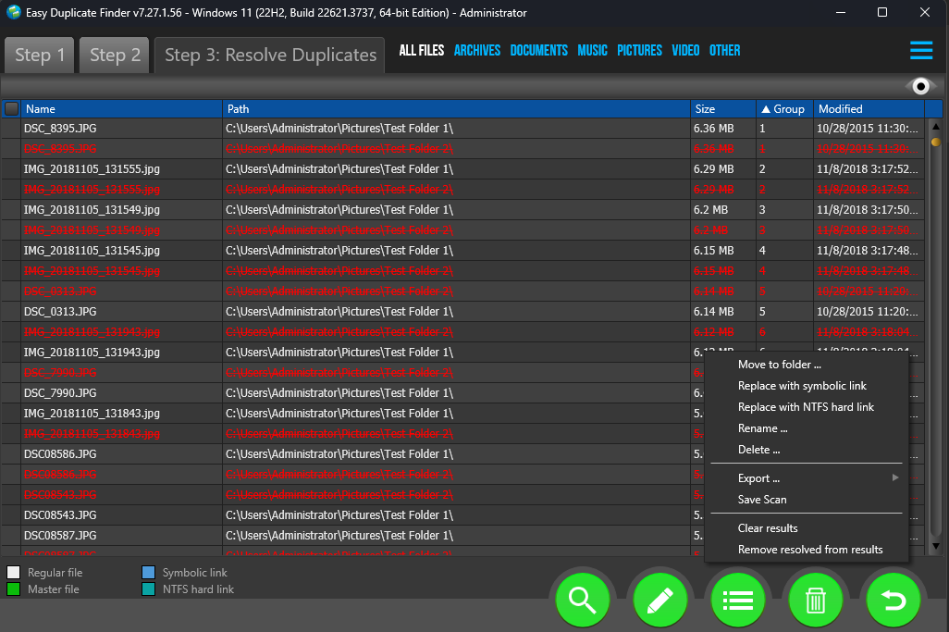

Action button

Figure : Actions button – Clearing results

After you click the **Remove resolved from results** option, the resolved file along with their originals will be removed from this easel.

Performing an Undo Action

The Easy Duplicate FinderTM application provides the Undo action feature using which you can undo all actions which are reversable and done in a sequence without a new scan being performed in this sequence. i.e., the user can perform unlimited Undo actions if no new scan is performed or no irreversible action has been performed in the sequence of actions.



Action button

Figure : Actions button – Undo

Consider a scenario in which we intend to perform deleting of the identified duplicates in the below fashion –

1. First, we identify all duplicate
2. Then, we intend to **Move all duplicate files to Recycle Bin**
3. And finally, we **perform the undo operation**

**Warning:** Consider in the above example, if we **delete all duplicates permanently** instead of **moving them to recycle bin**, then the whole Last-In-First-Out (LIFO) Undo Actions Stack is lost as the First Out step itself is irreversible. In other words, only a sequence of unlimited reversible actions can be undone so long as a new scan performed.

Now after we have performed the actions in steps 1 through 3, try to undo these actions one by one by clicking the Undo button from the Scan Details page actions menu. Each of these actions will be reversed successfully.

The next chapter enables you to get the Premium Free Trial of the Easy Duplicate Finder TM application that you just installed.

# Getting the Premium Free Trial

An unregistered & newly installed EDF application installation allows you to remove up to 10 duplicate files. A registered Premium Free Trial adds 20 additional duplicate file removals to your account.

The steps described below enable you to get the **Premium Free Trial** of the Easy Duplicate FinderTM application. You can do so in the following 2 ways –

* **Via the Free Trial buttons or link**
* **Via the Register Now Button in the EDF Application Menu**

**Tip:** Click the links provided above to navigate to their corresponding sections.

## Via the Free Trial buttons or link

The steps described below enable you to get the Premium Free Trial of the EDF application via the 2 buttons & 1 link provided on the EDF application default screen –

1. After you have clicked on the desktop icon of Easy Duplicate FinderTM application, your EDF application will be launched as depicted in the figure below –



Figure – Easy Duplicate FinderTM default screen

1. Click **Premium Free Trial / Get the Premium Free Trial** buttons or the **Premium Free Trial** link as depicted in the previous figure. The Premium Free Trial sign up form is displayed as depicted in the figure below –

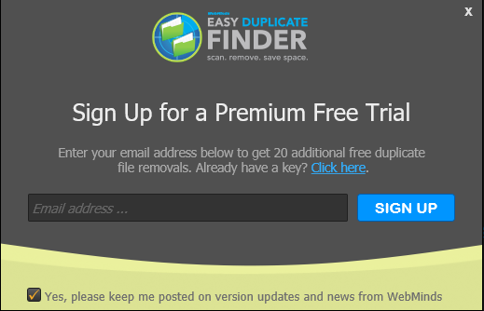

Figure – Specifying your registration details

**Tip:** In case you have already registered, click the **Click here** link provided above the **Sign Up** button as depicted in the figure above. The Activation popup will be displayed which enables you to specify your email address & your activation key.

**Reference:** For more information, refer to the **Purchasing your**  chapter.

1. Specify your email address & click **Sign Up**. A confirmation message is displayed confirming that you have successfully registered for the premium free trial. This message also confirms that 20 additional duplicate file removals have been added to your account.
2. Click **Continue** on the confirmation message popup to continue evaluating your EDF application installation.

**Note:** The Premium Free Trial button on the EDF application default screen is replaced by the **Activate** button.

## Via the Register Now Button in the EDF Application Menu

The steps described below enable you to register the EDF application via the Register Button of EDF application –

1. After you launch the EDF application, the default screen is displayed as depicted in the figure below –



Figure – Easy Duplicate FinderTM default screen

1. Click **Start Scan** as depicted in the previous figure. The EDF application main screen is displayed as depicted in the figure below –



Figure – The EDF application main screen

1. Click the Hamburger Menu button on the top right-hand corner of this screen as depicted in the previous figure. The Hamburger menu will be displayed as depicted in the figure above.
2. From the Hamburger menu, click **Register Now**. The EDF Product Key Details popup is displayed as depicted in the figure below –



Figure – Specifying your registration details

**Tip:** In case you have already registered, this screen will not be displayed; instead, an activation pop-up will be displayed at this step.

**Reference:** For more information, refer to the **Purchasing your**  chapter.

1. Specify your email address & click **Sign Up**. A confirmation message is displayed confirming that you have successfully registered for the premium free trial. This message also confirms that 20 additional duplicate file removals have been added to your account.
2. Click **Continue** on the confirmation message popup to continue evaluating your EDF application installation.

**Note:** The Premium Free Trial button on the EDF application default screen is replaced by the **Activate** button.

**Reference:** For more information, refer to the **Purchasing your License Key** chapter.

The next chapter describes steps that enable you to **Purchase your License Key**.

# Purchasing your License Key

In case you have not purchased a license key for your Easy Duplicate FinderTM application yet, you can utilize the steps described below –

1. You can purchase a license key by clicking the **Upgrade** link available in the menu on the Easy Duplicate Finder TM homepage as depicted in the figure below –



Figure – Purchasing your License key – step 1

1. From the main menu, click **Upgrade**. The Secure Checkout webpage is displayed as depicted in the figure below –

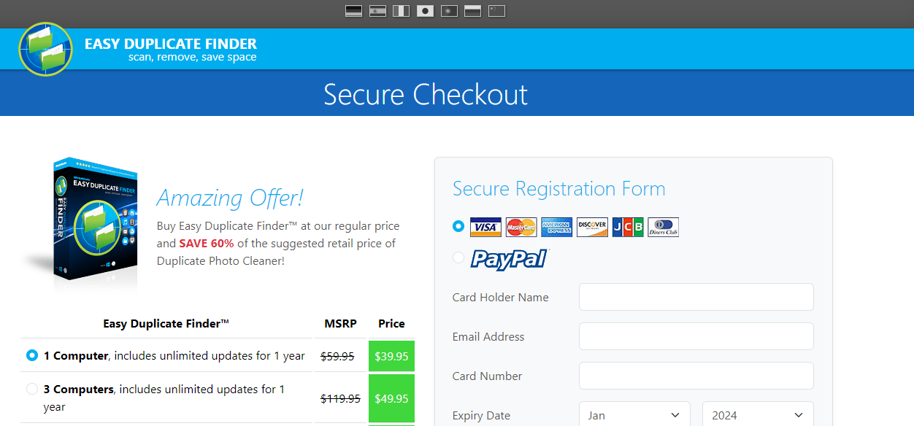

Figure – Purchasing your License Key – step 2

1. Specify the details required on this page and click **Buy Now**. After your license key purchase transaction is successful, a confirmation will be displayed and you will receive the license key details via email to the email address you specified on this form.

The next chapter describes steps that enable you to **Activate your EDF Installation**.

# Activating your EDF Installation

After you have received your license key details via email, you can activate your Easy Duplicate FinderTM application installation in the following 2 ways –

* **Via the Activate buttons or link**
* **Via the Register Now Button in the EDF Application Menu**

**Tip:** Click the links provided above to navigate to their corresponding sections.

## Via the Activate buttons or link

The steps described below enable you to activate your EDF application installation via the 2 buttons & 1 link provided on the EDF application default screen –

1. After you have clicked on the desktop icon of Easy Duplicate FinderTM application, your EDF application will be launched as depicted in the figure below –

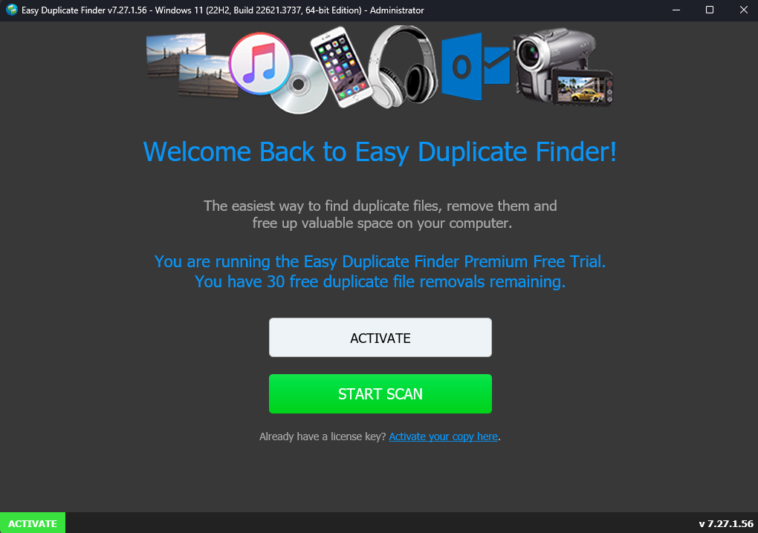

Figure – Easy Duplicate FinderTM default screen

1. Click **Activate** buttons or the **Activate your copy here** link as depicted in the previous figure. The Activation popup is displayed as depicted in the figure below –

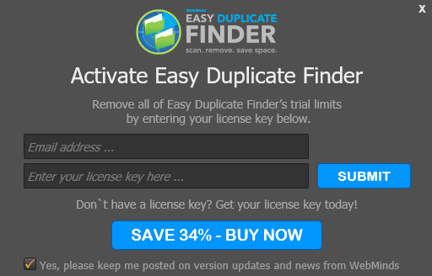

Figure – Specifying your registration details

1. Specify your email address & license key details & click **Submit**. After a successful validation of the details you specified, a confirmation message is displayed confirming that you have successfully activated your EDF application installation.
2. Click **Continue** on the confirmation message popup to continue utilizing your EDF application installation.

**Tip:** After you have successfully activated your EDF application installation, the Activate button will be removed. You can also choose to directly navigate to the main screen after application launch by clicking the **Don’t want to see this window, Go here** link from the EDF application default screen. (Recommended)

## Via the Register Now Button in the EDF Application Menu

The steps described below enable you to register the EDF application via the Register Button of EDF application –

1. After you launch the EDF application, the default screen is displayed as depicted in the figure below –



Figure – Easy Duplicate FinderTM default screen

1. Click **Start Scan** as depicted in the previous figure. The EDF application main screen is displayed as depicted in the figure below –



Figure – The EDF application main screen

1. Click the Hamburger Menu button on the top right-hand corner of this screen as depicted in the previous figure. The Hamburger menu will be displayed as depicted in the figure above.
2. From the Hamburger menu, click **Register Now**. The EDF Product Key Details popup is displayed as depicted in the figure below –



Figure – Specifying your registration details

1. Specify your email address & license key details & click **Submit**. After a successful validation of the details you specified, a confirmation message is displayed confirming that you have successfully activated your EDF application installation.
2. Click **Continue** on the confirmation message popup to continue utilizing your EDF application installation.

**Tip:** After you have successfully activated your EDF application installation, the Activate button will be removed. You can also choose to directly navigate to the main screen after application launch by clicking the **Don’t want to see this window, Go here** link from the EDF application default screen. (Recommended)

The next chapter describes steps that enable you to **Entering a New Key**.

# Entering a New Key

In case your existing license key has expired and you have received a new key after you have successfully purchased & received the same, you can enter this new key by utilizing the steps described below –

1. After you launch the EDF application, the main screen is displayed as depicted in the figure below –

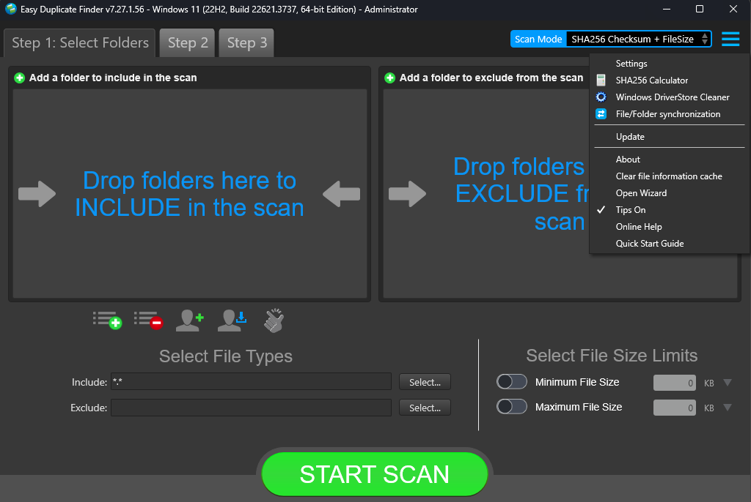

Figure – EDF application main screen

1. Click the Hamburger Menu button on the top right-hand corner of this screen as depicted in the figure above. The Hamburger menu will be displayed as depicted in the figure above.
2. From the Hamburger menu, click **About** as depicted in the previous figure. The EDF Product Key Details popup is displayed as depicted in the figure below –



Figure – Removing EDF application license key details – About popup

1. Click the **Enter new Key** button as depicted in the figure above. The license key activation popup is displayed with your registered email address duly populated in the email address field as depicted in the figure below –

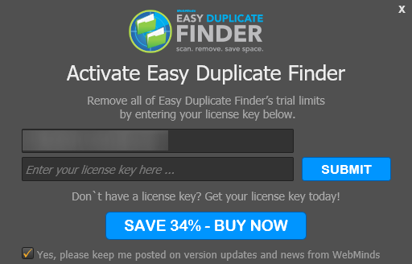

Figure – Activating EDF application – step 2

**Tip:** You can change the email address if you used a different email address to purchase a new key.

1. Specify your **Email Address** & **License Key** and click **Submit**. A successful license key activation message popup is displayed also confirming that the registration has also been successful as depicted in the figure below –

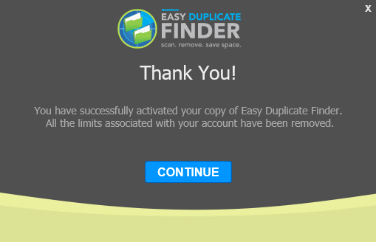

Figure – EDF application license key activation successful

1. Click **Continue** to continue utilizing your EDF application installation. Now the 10-item duplicate photo limit will be removed and you can utilize all features of this application freely without any limitations.

The next chapter describes steps that enable you to **Remove your EDF License Key details**.

# Removing your EDF License Details

In case you intend to remove your EDF application license details so that you can use it on another system, you can utilize the steps described below –

**Warning:** You can only activate & remove your EDF license details 3 times post which this license will automatically expire.

1. After you launch the EDF application, the main screen is displayed as depicted in the figure below –



Figure – EDF application main screen

1. Click the Hamburger Menu button on the top right-hand corner of this screen as depicted in the figure above. The Hamburger menu will be displayed as depicted in the figure above.
2. From the Hamburger menu, click **About** as depicted in the previous figure. The EDF Product Key Details popup is displayed as depicted in the figure below –



Figure – Removing EDF application license key details – About popup

1. Click the **Remove Key** button as depicted in the figure above. The license key removal confirmation popup is displayed as depicted in the figure below –



Figure – Removing license key details confirmation popup

1. Click the **Yes** button. A successful license key removal confirmation messages is displayed as depicted in the figure below –



Figure – Successful Removal of EDF application license key details

1. Click **OK** to continue. Now you can reuse this license key on another computer.

**Warning:** You can only activate & remove your EDF license details 3 times post which this license will automatically expire.

The next chapter describes steps that enable you to **Perform a SHA256 Checksum + FileSize Scan**.

# Performing a SHA256 Checksum + FileSize Scan

In the SHA256 + FileSize scan the Easy Duplicate FinderTM application enables you compare files from the specified target folders by comparing each of the files by taking the SHA256 checksum & the size of the files.

A SHA256 checksum is a string of numbers and letters which is calculated using the SHA256 algorithm for a given file. Even a small change in the file contents changes the SHA256 checksum vastly. The SHA256 checksum and the size of the file are taken into consideration while performing this scan during duplicate identification.

The steps described below enable you to perform a SHA256 Checksum + FileSize scan –

1. Navigate to the Easy Duplicate FinderTM application main screen as depicted in the figure below –

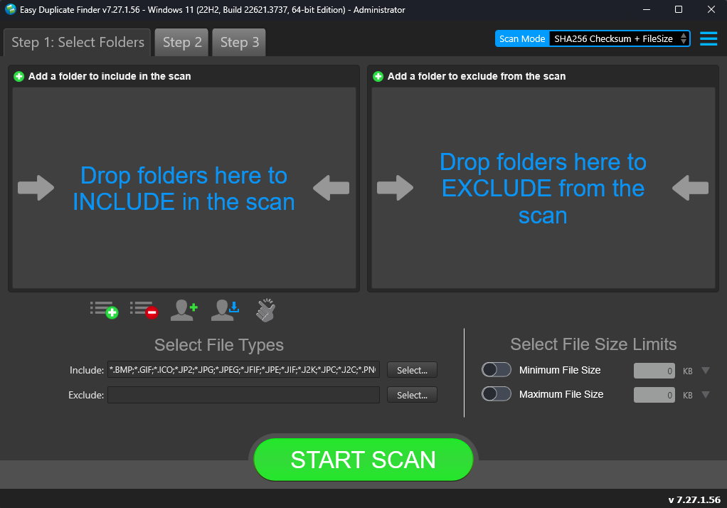

Figure – Performing a SHA256 Checksum + FileSize Scan – EDF main screen

**Reference:** For more information, refer to **The Main Screen Description** section.

Below are the functions along with a description of the parameters that you can tweak before you start a SHA256 Checksum + FileSize scan –

* + **Include folder (s) –** Clicking on the blue INCLUDE text on the left easel or by dragging a folder and dropping it in the area as depicted in the figure above, enables you to select a target folder which is to be scanned
  + **Exclude folder (s) –** Clicking on the blue EXCLUDE text on the right easel or by dragging a folder and dropping it in the area as depicted in the figure above, enables you to select a target folder which is to be excluded from the scan
  + **Import last scan –** Clicking this button opens a menu from which you can select this option to import the target folders of the last scan that you performed
  + **Import saved scan –** Clicking this button opens a menu from which you can select this option to import the target folders of the last scan that you performed and saved as a **.edfscan** file
  + **Import from Excel –** Clicking this button opens a menu from which you can select this option to import the target folders of the last scan that you performed and exported as an MS Excel file
  + **Clear List –** Clicking this button clears the target folder list

**Tip:** To clear the Exclude folder list perform a **Shift + Click** action

* + **Load settings profile:** Clicking this button enables you to load a scan profile settings that you saved as a **.edfsp** file
  + **Save settings profile:** Clicking this button enables you to save this scan profile settings as a **.edfsp** file
  + **Load the predefined “Easy Scan” profile:** Clicking this button enables you to load the predefined easy scan profile for this scan
  + **File Types –** Clicking the Select button in this area as depicted in the figure above enables you to specify which file types are to be scanned for duplicates and which are to be excluded
  + **File Size Limits –** Specifying the maximum & minimum file sizes enables you to specify the size range of the files to be scanned. Then you can specify the numerical values for both maximum & minimum limits and select the adjacent drop-downs to specify whether the limits must be considered in bytes (B), kilobytes (KB), megabytes (MB), or gigabytes (GB).

1. Click the blue INCLUDE text on the left or drag & drop a target folder that you intend to scan. You may also specify folders to be excluded as per your requirements. The specified folder is selected and listed in target folder list as depicted in the figure below –

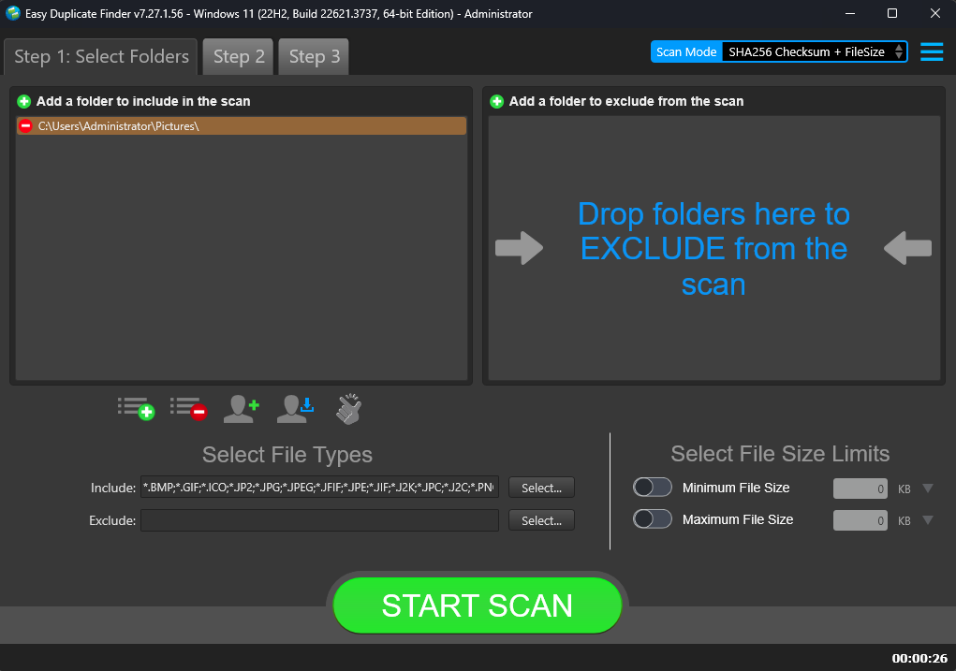

Figure – Selecting one or more folders

**Tip:** You can add more folders in the target folder list by clicking the green Add folders button as depicted in the figure above in both the INCLUDE & EXCLUDE easels.

1. Specify the scan parameters as per your discretion and click **Start Scan**. Once the scan is finished, the scan results summary page is displayed as depicted in the figure below –

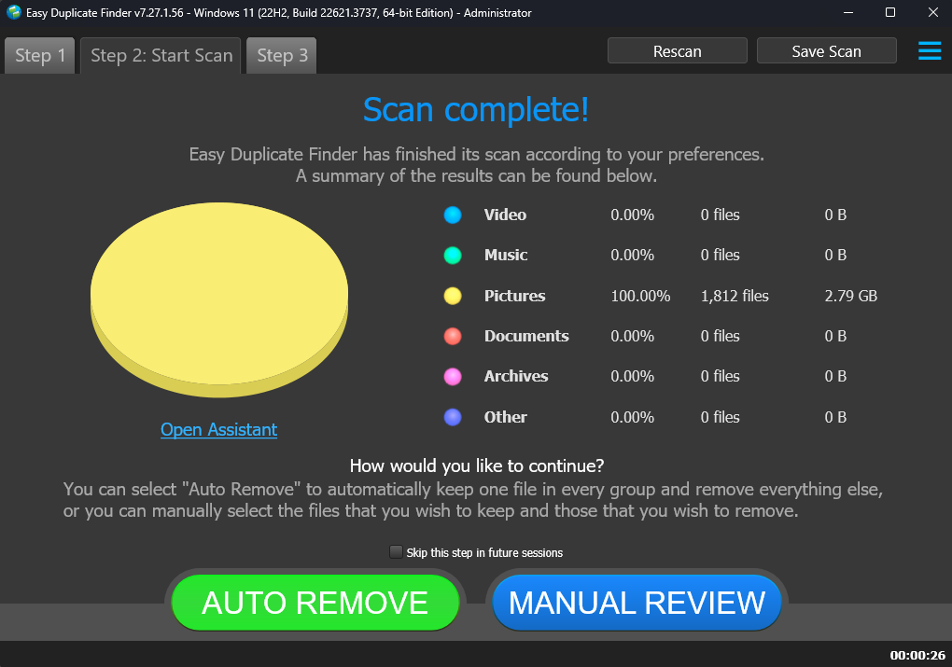

Figure – Scan results summary page

**Tip:** Clicking **AUTO REMOVE** will remove the identified duplicates automatically.

**Tip:** Clicking **Skip this step in future sessions** will not display this screen in future.

**Reference:** Clicking **Open Assistant** opens the Assistant wizard. For more information, refer to the **Using the Assistant on the Scan Summary Page** section.

1. Click **MANUAL REVIEW**. The scan result details page is displayed as depicted in the figure below –

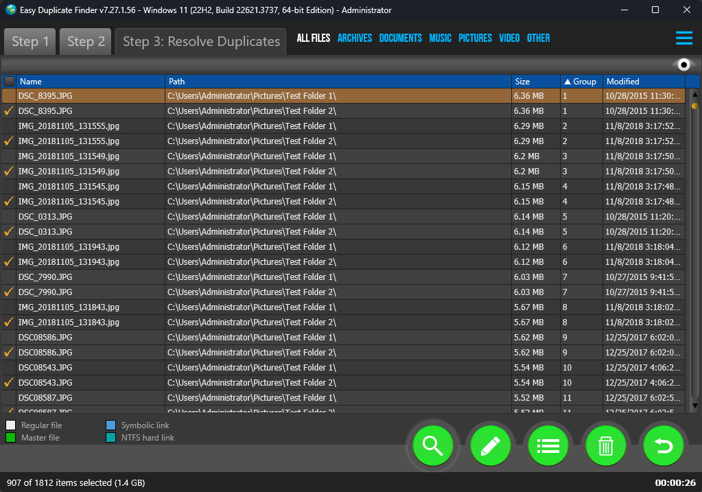

Figure – Scan results details page

**Tip:** To preview the thumbnail of a selected file, click the **Preview** button provided on the top right-hand corner of this table.

**Tip:** You can also quickly view by their types by clicking their **File Type Links** provided just next to the Step 3 tab.

**Reference:** To save this scan, refer to **Saving a Scan** section. To import this scan later, refer to **Importing a Scan** section.

**Reference:** To perform multiple types of selections, refer to **Performing Multiple Types of Selections on the Scan Results page** section.

**Reference:** To export your scan results details as a file, refer to **Exporting your Scan Result Details as a File** section.

**Reference:** To clear the displayed scan results, refer to **Clearing the Displayed Scan Results from Scan Results page** section.

1. After you have selected the duplicate files that you intend to delete or move or in case you intend to replace the duplicate files with symbolic links or NTFS hard links, from the top right-hand corner on the scan results page, click the corresponding buttons as depicted in the figure below –



Figure – Scan Details Page Actions Menu

**Reference:** Refer to Error! Reference source not found. section for a detailed description of the buttons available on the Scan Details Page Actions Menu.

The next chapter describes steps that enable you to **Perform a Byte-by-Byte Comparison Scan**.

# Performing a Byte-By-Byte Comparison Scan

In the Byte-by-Byte Comparison scan the Easy Duplicate FinderTM application enables you compare files from the specified target folders by comparing each byte of the files.

The steps described below enable you to perform a Byte-by-Byte Comparison scan –

1. Navigate to the Easy Duplicate FinderTM application main screen as depicted in the figure below –



Figure – Performing a Byte-by-Byte Comparison Scan – EDF main screen

**Reference:** For more information, refer to **The Main Screen Description** section.

1. From the scan mode drop-down, select the Byte-by-Byte Comparison option. The Byte-by-Byte Comparison scan screen is displayed as depicted in the figure below –

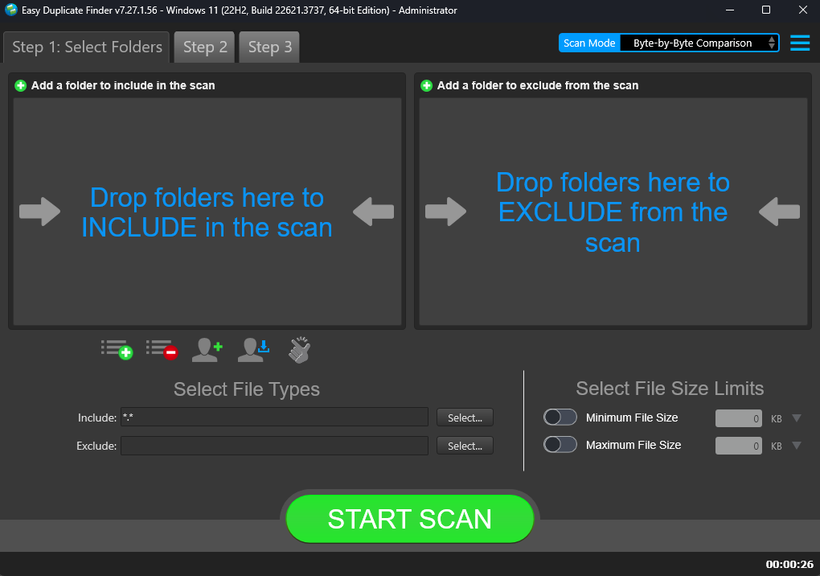

Figure – Performing a Byte-by-Byte Comparison Scan – EDF main screen

**Reference:** For more information, refer to **The Main Screen Description** section.

Below are the functions along with a description of the parameters that you can tweak before you start a Byte-by-Byte Comparison scan –

* + **Include folder (s) –** Clicking on the blue INCLUDE text on the left easel or by dragging a folder and dropping it in the area as depicted in the figure above, enables you to select a target folder which is to be scanned
  + **Exclude folder (s) –** Clicking on the blue EXCLUDE text on the right easel or by dragging a folder and dropping it in the area as depicted in the figure above, enables you to select a target folder which is to be excluded from the scan
  + **Import last scan –** Clicking this button opens a menu from which you can select this option to import the target folders of the last scan that you performed
  + **Import saved scan –** Clicking this button opens a menu from which you can select this option to import the target folders of the last scan that you performed and saved as a **.edfscan** file
  + **Import from Excel –** Clicking this button opens a menu from which you can select this option to import the target folders of the last scan that you performed and exported as an MS Excel file
  + **Clear List –** Clicking this button clears the target folder list

**Tip:** To clear the Exclude folder list perform a **Shift + Click** action

* + **Load settings profile:** Clicking this button enables you to load a scan profile settings that you saved as a **.edfsp** file
  + **Save settings profile:** Clicking this button enables you to save this scan profile settings as a **.edfsp** file
  + **Load the predefined “Easy Scan” profile:** Clicking this button enables you to load the predefined easy scan profile for this scan
  + **File Types –** Clicking the Select button in this area as depicted in the figure above enables you to specify which file types are to be scanned for duplicates and which are to be excluded
  + **File Size Limits –** Specifying the maximum & minimum file sizes enables you to specify the size range of the files to be scanned. Then you can specify the numerical values for both maximum & minimum limits and select the adjacent drop-downs to specify whether the limits must be considered in bytes (B), kilobytes (KB), megabytes (MB), or gigabytes (GB).

1. Click the blue INCLUDE text on the left or drag & drop a target folder that you intend to scan. You may also specify folders to be excluded as per your requirements. The specified folder is selected and listed in target folder list as depicted in the figure below –

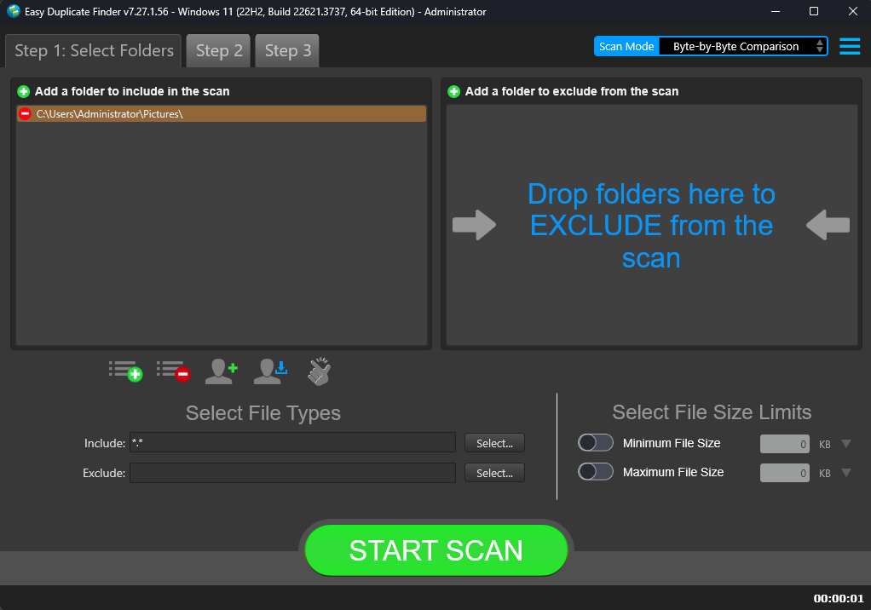

Figure – Selecting one or more folders

**Tip:** You can add more folders in the target folder list by clicking the green Add folders button as depicted in the figure above in both the INCLUDE & EXCLUDE easels.

1. Specify the scan parameters as per your discretion and click **Start Scan**. Once the scan is finished, the scan results summary page is displayed as depicted in the figure below –



Figure – Scan results summary page

**Tip:** Clicking **AUTO REMOVE** will remove the identified duplicates automatically.

**Tip:** Clicking **Skip this step in future sessions** will not display this screen in future.

**Reference:** Clicking **Open Assistant** opens the Assistant wizard. For more information, refer to the **Using the Assistant on the Scan Summary Page** section.

1. Click **MANUAL REVIEW**. The scan result details page is displayed as depicted in the figure below –



Figure – Scan results details page

**Tip:** To preview the thumbnail of a selected file, click the **Preview** button provided on the top right-hand corner of this table.

**Tip:** You can also quickly view by their types by clicking their **File Type Links** provided just next to the Step 3 tab.

**Reference:** To save this scan, refer to **Saving a Scan** section. To import this scan later, refer to **Importing a Scan** section.

**Reference:** To perform multiple types of selections, refer to **Performing Multiple Types of Selections on the Scan Results page** section.

**Reference:** To export your scan results details as a file, refer to **Exporting your Scan Result Details as a File** section.

**Reference:** To clear the displayed scan results, refer to **Clearing the Displayed Scan Results from Scan Results page** section.

1. After you have selected the duplicate files that you intend to delete or move or in case you intend to replace the duplicate files with symbolic links or NTFS hard links, from the top right-hand corner on the scan results page, click the corresponding buttons as depicted in the figure below –



Figure – Scan Details Page Actions Menu

**Reference:** Refer to **Scan Detail Page Actions Menu Descriptions** section for a detailed description of the buttons available on the Scan Details Page Actions Menu.

The next chapter describes steps that enable you to **Perform a Filename Only Scan**.

# Performing a Filename Only Scan

In the Filename only scan the Easy Duplicate FinderTM application enables you compare files from the specified target folders by comparing only the names of the files.

The steps described below enable you to perform a Filename only scan –

1. Navigate to the Easy Duplicate FinderTM application main screen as depicted in the figure below –



Figure – Performing a Filename Only Scan – EDF main screen

**Reference:** For more information, refer to **The Main Screen Description** section.

1. From the scan mode drop-down, select the Filename only option. The Filename only scan screen is displayed as depicted in the figure below –

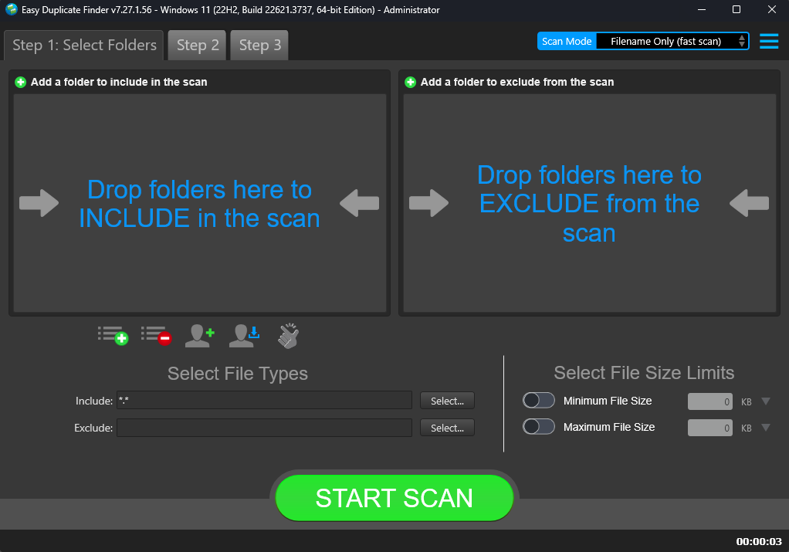

Figure – Performing a Filename Only Scan – EDF main screen

**Reference:** For more information, refer to **The Main Screen Description** section.

Below are the functions along with a description of the parameters that you can tweak before you start a Filename only scan –

* + **Include folder (s) –** Clicking on the blue INCLUDE text on the left easel or by dragging a folder and dropping it in the area as depicted in the figure above, enables you to select a target folder which is to be scanned
  + **Exclude folder (s) –** Clicking on the blue EXCLUDE text on the right easel or by dragging a folder and dropping it in the area as depicted in the figure above, enables you to select a target folder which is to be excluded from the scan
  + **Import last scan –** Clicking this button opens a menu from which you can select this option to import the target folders of the last scan that you performed
  + **Import saved scan –** Clicking this button opens a menu from which you can select this option to import the target folders of the last scan that you performed and saved as a **.edfscan** file
  + **Import from Excel –** Clicking this button opens a menu from which you can select this option to import the target folders of the last scan that you performed and exported as an MS Excel file
  + **Clear List –** Clicking this button clears the target folder list

**Tip:** To clear the Exclude folder list perform a **Shift + Click** action

* + **Load settings profile:** Clicking this button enables you to load a scan profile settings that you saved as a **.edfsp** file
  + **Save settings profile:** Clicking this button enables you to save this scan profile settings as a **.edfsp** file
  + **Load the predefined “Easy Scan” profile:** Clicking this button enables you to load the predefined easy scan profile for this scan
  + **File Types –** Clicking the Select button in this area as depicted in the figure above enables you to specify which file types are to be scanned for duplicates and which are to be excluded
  + **File Size Limits –** Specifying the maximum & minimum file sizes enables you to specify the size range of the files to be scanned. Then you can specify the numerical values for both maximum & minimum limits and select the adjacent drop-downs to specify whether the limits must be considered in bytes (B), kilobytes (KB), megabytes (MB), or gigabytes (GB).

1. Click the blue INCLUDE text on the left or drag & drop a target folder that you intend to scan. You may also specify folders to be excluded as per your requirements. The specified folder is selected and listed in target folder list as depicted in the figure below –

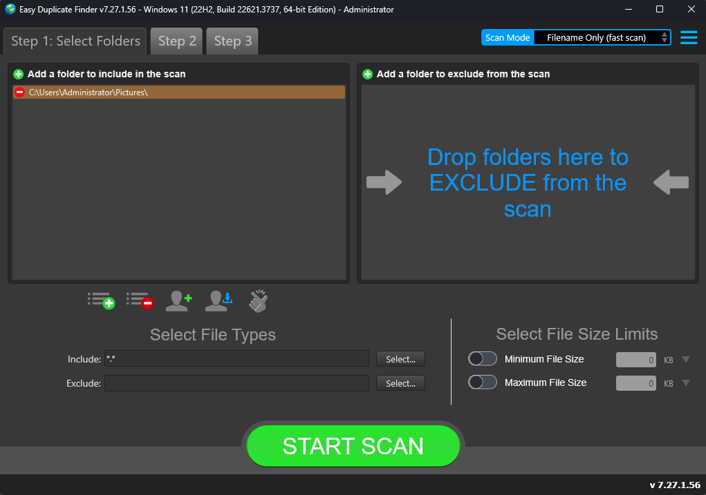

Figure – Selecting one or more folders

**Tip:** You can add more folders in the target folder list by clicking the green Add folders button as depicted in the figure above in both the INCLUDE & EXCLUDE easels.

1. Specify the scan parameters as per your discretion and click **Start Scan**. Once the scan is finished, the scan results summary page is displayed as depicted in the figure below –

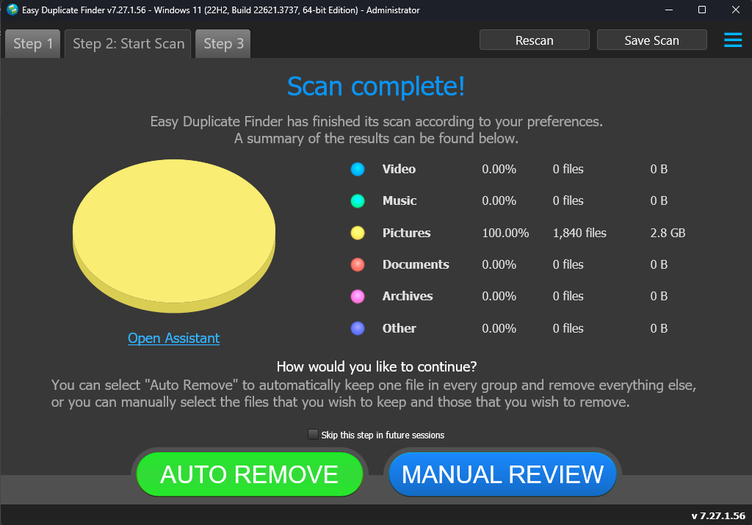

Figure – Scan results summary page

**Tip:** Clicking **AUTO REMOVE** will remove the identified duplicates automatically.

**Tip:** Clicking **Skip this step in future sessions** will not display this screen in future.

**Reference:** Clicking **Open Assistant** opens the Assistant wizard. For more information, refer to the **Using the Assistant on the Scan Summary Page** section.

1. Click **MANUAL REVIEW**. The scan result details page is displayed as depicted in the figure below –



Figure – Scan results details page

**Tip:** To preview the thumbnail of a selected file, click the **Preview** button provided on the top right-hand corner of this table.

**Tip:** You can also quickly view by their types by clicking their **File Type Links** provided just next to the Step 3 tab.

**Reference:** To save this scan, refer to **Saving a Scan** section. To import this scan later, refer to **Importing a Scan** section.

**Reference:** To perform multiple types of selections, refer to **Performing Multiple Types of Selections on the Scan Results page** section.

**Reference:** To export your scan results details as a file, refer to **Exporting your Scan Result Details as a File** section.

**Reference:** To clear the displayed scan results, refer to **Clearing the Displayed Scan Results from Scan Results page** section.

1. After you have selected the duplicate files that you intend to delete or move or in case you intend to replace the duplicate files with symbolic links or NTFS hard links, from the top right-hand corner on the scan results page, click the corresponding buttons as depicted in the figure below –



Figure – Scan Details Page Actions Menu

**Reference:** Refer to **Scan Detail Page Actions Menu Descriptions** section for a detailed description of the buttons available on the Scan Details Page Actions Menu.

The next chapter describes steps that enable you to **Perform a Music Scan**.

# Performing a Music Scan

In the Music scan the Easy Duplicate FinderTM application enables you compare files from the specified target folders by identifying whether the files being compared are identical or within the sensitivity percentage set in the Fingerprint comparison setting on the Settings Panel.

**Reference:** For more information, refer to **The Music Scan tab** section.

The steps described below enable you to perform a Music scan –

1. Navigate to the Easy Duplicate FinderTM application main screen as depicted in the figure below –



Figure – Performing a Music Scan – EDF main screen

**Reference:** For more information, refer to **The Main Screen Description** section.

1. From the scan mode drop-down, select the Music scan option. The Music scan screen is displayed as depicted in the figure below –

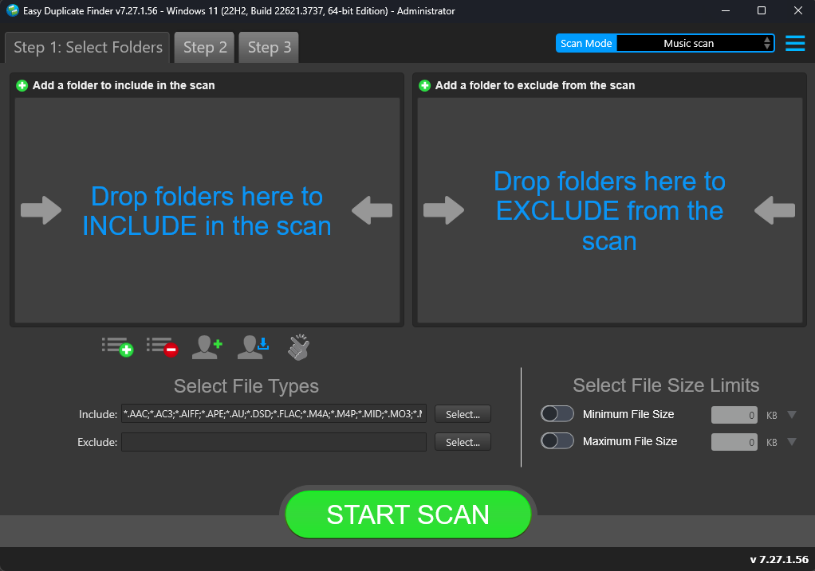

Figure – Performing a Music Scan – EDF main screen

**Reference:** For more information, refer to **The Main Screen Description** section.

Below are the functions along with a description of the parameters that you can tweak before you start a Music scan –

* + **Include folder (s) –** Clicking on the blue INCLUDE text on the left easel or by dragging a folder and dropping it in the area as depicted in the figure above, enables you to select a target folder which is to be scanned
  + **Exclude folder (s) –** Clicking on the blue EXCLUDE text on the right easel or by dragging a folder and dropping it in the area as depicted in the figure above, enables you to select a target folder which is to be excluded from the scan
  + **Import last scan –** Clicking this button opens a menu from which you can select this option to import the target folders of the last scan that you performed
  + **Import saved scan –** Clicking this button opens a menu from which you can select this option to import the target folders of the last scan that you performed and saved as a **.edfscan** file
  + **Import from Excel –** Clicking this button opens a menu from which you can select this option to import the target folders of the last scan that you performed and exported as an MS Excel file
  + **Clear List –** Clicking this button clears the target folder list

**Tip:** To clear the Exclude folder list perform a **Shift + Click** action

* + **Load settings profile:** Clicking this button enables you to load a scan profile settings that you saved as a **.edfsp** file
  + **Save settings profile:** Clicking this button enables you to save this scan profile settings as a **.edfsp** file
  + **Load the predefined “Easy Scan” profile:** Clicking this button enables you to load the predefined easy scan profile for this scan
  + **File Types –** Clicking the Select button in this area as depicted in the figure above enables you to specify which file types are to be scanned for duplicates and which are to be excluded
  + **File Size Limits –** Specifying the maximum & minimum file sizes enables you to specify the size range of the files to be scanned. Then you can specify the numerical values for both maximum & minimum limits and select the adjacent drop-downs to specify whether the limits must be considered in bytes (B), kilobytes (KB), megabytes (MB), or gigabytes (GB).

1. Click the blue INCLUDE text on the left or drag & drop a target folder that you intend to scan. You may also specify folders to be excluded as per your requirements. The specified folder is selected and listed in target folder list as depicted in the figure below –

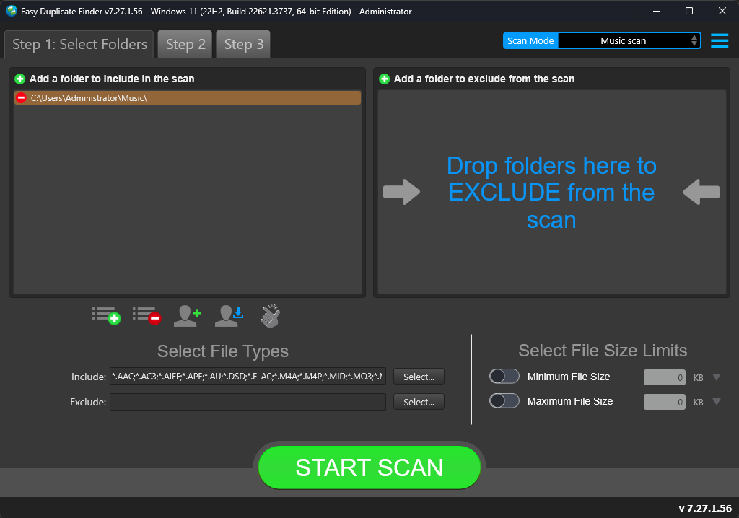

Figure – Selecting one or more folders

**Tip:** You can add more folders in the target folder list by clicking the green Add folders button as depicted in the figure above in both the INCLUDE & EXCLUDE easels.

1. Specify the scan parameters as per your discretion and click **Start Scan**. Once the scan is finished, the scan results summary page is displayed as depicted in the figure below –

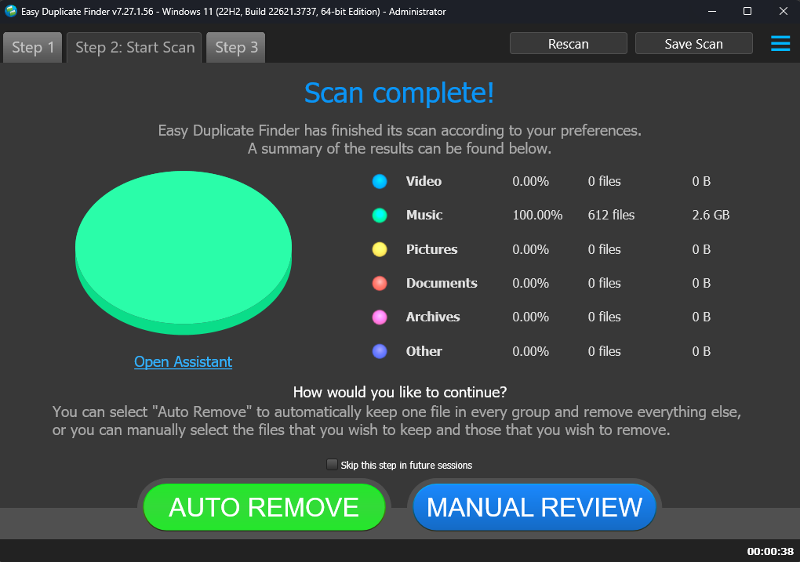

Figure – Scan results summary page

**Tip:** Clicking **AUTO REMOVE** will remove the identified duplicates automatically.

**Tip:** Clicking **Skip this step in future sessions** will not display this screen in future.

**Reference:** Clicking **Open Assistant** opens the Assistant wizard. For more information, refer to the **Using the Assistant on the Scan Summary Page** section.

1. Click **MANUAL REVIEW**. The scan result details page is displayed as depicted in the figure below –

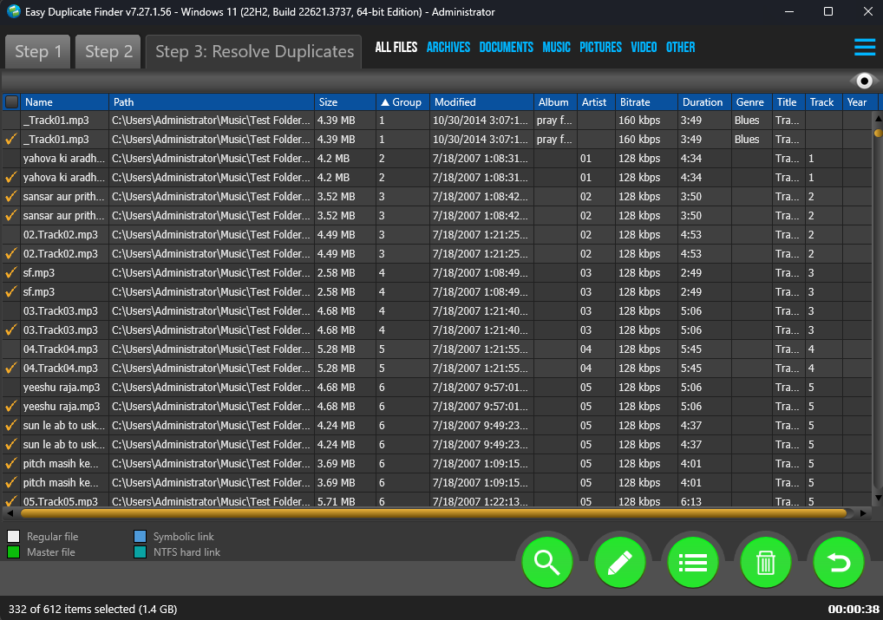

Figure – Scan results details page

**Tip:** To preview listening to the selected file in your default media player, click the **Preview** button provided on the top right-hand corner of this table.

**Tip:** You can also quickly view by their types by clicking their **File Type Links** provided just next to the Step 3 tab.

**Reference:** To save this scan, refer to **Saving a Scan** section. To import this scan later, refer to **Importing a Scan** section.

**Reference:** To perform multiple types of selections, refer to **Performing Multiple Types of Selections on the Scan Results page** section.

**Reference:** To export your scan results details as a file, refer to **Exporting your Scan Result Details as a File** section.

**Reference:** To clear the displayed scan results, refer to **Clearing the Displayed Scan Results from Scan Results page** section.

1. After you have selected the duplicate files that you intend to delete or move or in case you intend to replace the duplicate files with symbolic links or NTFS hard links, from the top right-hand corner on the scan results page, click the corresponding buttons as depicted in the figure below –



Figure – Scan Details Page Actions Menu

**Reference:** Refer to **Scan Detail Page Actions Menu Descriptions** section for a detailed description of the buttons available on the Scan Details Page Actions Menu.

The next chapter describes steps that enable you to **Perform an Outlook Mail Scan**.

# Performing an Outlook Mail Scan

In the Outlook Mail scan the Easy Duplicate FinderTM application enables you compare your outlook emails from the specified target folders by comparing each byte of the files.

The steps described below enable you to perform a Byte-by-Byte Comparison Scan –

1. Navigate to the Easy Duplicate FinderTM application main screen as depicted in the figure below –



Figure – Performing a Byte-by-Byte Comparison Scan – EDF main screen

**Reference:** For more information, refer to **The Main Screen Description** section.

1. From the scan mode drop-down, select the Music scan option. The Music scan screen is displayed as depicted in the figure below –

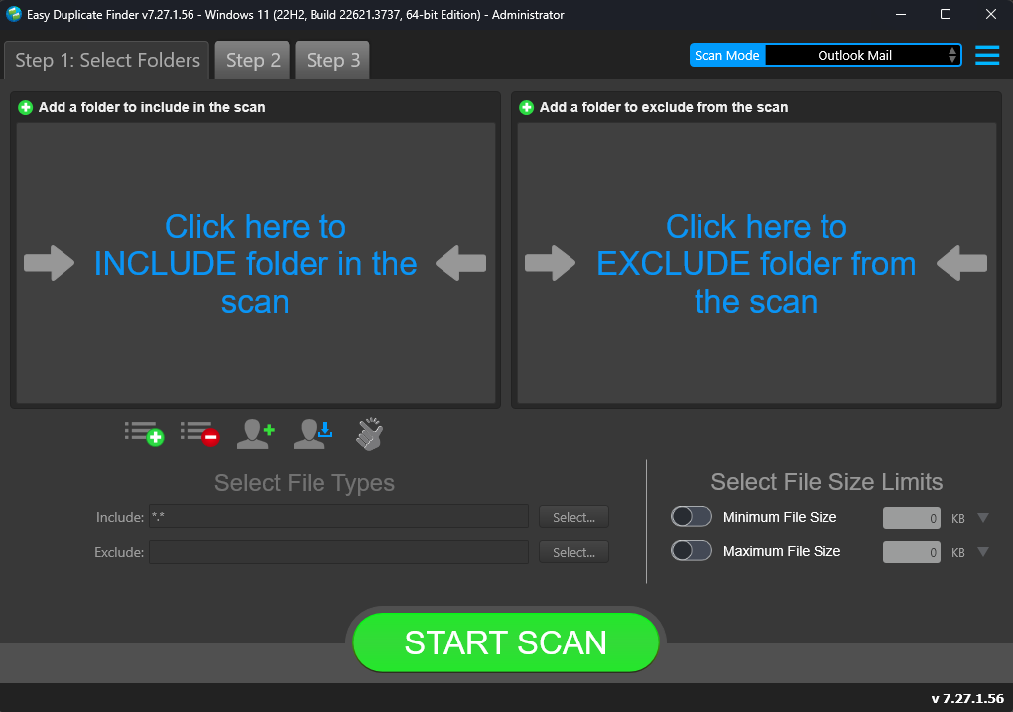

Figure – Performing a Byte-by-Byte Comparison Scan – EDF main screen

**Reference:** For more information, refer to **The Main Screen Description** section.

Below are the functions along with a description of the parameters that you can tweak before you start a Byte-by-Byte Comparison scan –

* + **Include folder (s) –** Clicking on the blue INCLUDE text on the left easel or by dragging a folder and dropping it in the area as depicted in the figure above, enables you to select a target folder (from your MS Outlook installation) which is to be scanned

**Tip:** Please click the MS Outlook taskbar button to bring it to the front. Then you will be able to select the required folders.

* + **Exclude folder (s) –** Clicking on the blue EXCLUDE text on the right easel or by dragging a folder and dropping it in the area as depicted in the figure above, enables you to select a target folder (from your MS Outlook installation) which is to be excluded from the scan

**Tip:** Please click the MS Outlook taskbar button to bring it to the front. Then you will be able to select the required folders.

* + **Import last scan –** Clicking this button opens a menu from which you can select this option to import the target folders of the last scan that you performed
  + **Import saved scan –** Clicking this button opens a menu from which you can select this option to import the target folders of the last scan that you performed and saved as a **.edfscan** file
  + **Import from Excel –** Clicking this button opens a menu from which you can select this option to import the target folders of the last scan that you performed and exported as an MS Excel file
  + **Clear List –** Clicking this button clears the target folder list

**Tip:** To clear the Exclude folder list perform a **Shift + Click** action

* + **Load settings profile:** Clicking this button enables you to load a scan profile settings that you saved as a **.edfsp** file
  + **Save settings profile:** Clicking this button enables you to save this scan profile settings as a **.edfsp** file
  + **Load the predefined “Easy Scan” profile:** Clicking this button enables you to load the predefined easy scan profile for this scan
  + **File Types –** Clicking the Select button in this area as depicted in the figure above enables you to specify which file types are to be scanned for duplicates and which are to be excluded
  + **File Size Limits –** Specifying the maximum & minimum file sizes enables you to specify the size range of the files to be scanned. Then you can specify the numerical values for both maximum & minimum limits and select the adjacent drop-downs to specify whether the limits must be considered in bytes (B), kilobytes (KB), megabytes (MB), or gigabytes (GB).

1. Click the blue INCLUDE text on the left or drag & drop a target folder that you intend to scan. You may also specify folders to be excluded as per your requirements. The specified folder is selected and listed in target folder list as depicted in the figure below –

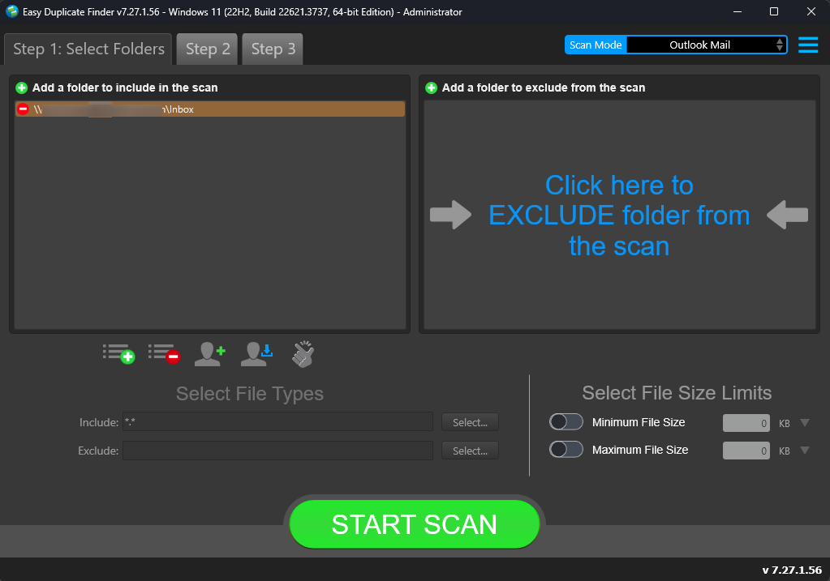

Figure – Selecting one or more folders

**Tip:** You can add more folders in the target folder list by clicking the green Add folders button as depicted in the figure above in both the INCLUDE & EXCLUDE easels.

1. Specify the scan parameters as per your discretion and click **Start Scan**. Once the scan is finished, the scan results summary page is displayed as depicted in the figure below –

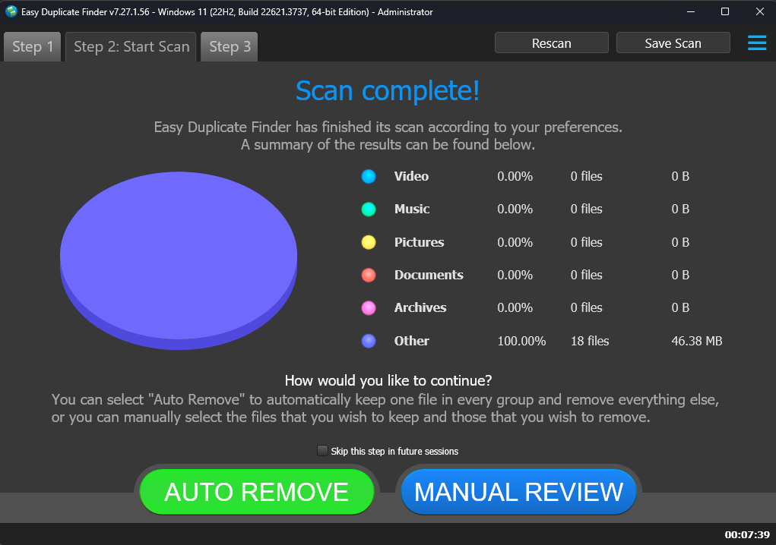

Figure – Scan results summary page

**Tip:** You will require allowing access from your MS Outlook installation from the popup that is displayed within this application. Specify the allowed timeframe as 10 minutes and click **Allow**.

**Tip:** Clicking **AUTO REMOVE** will remove the identified duplicates automatically.

**Tip:** Clicking **Skip this step in future sessions** will not display this screen in future.

1. Click **MANUAL REVIEW**. The scan result details page is displayed as depicted in the figure below –

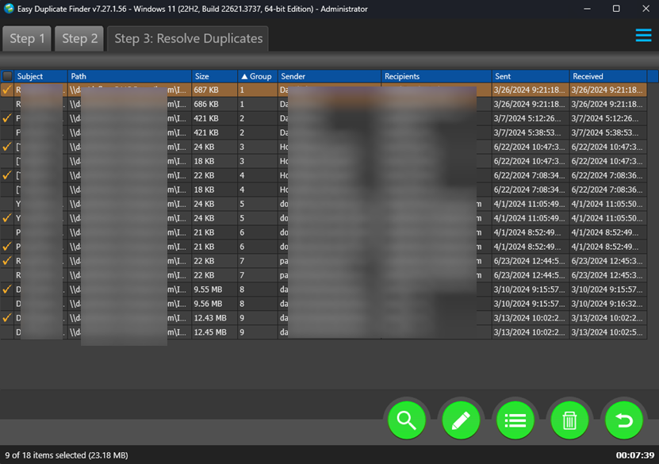

Figure – Scan results details page

**Reference:** To save this scan, refer to **Saving a Scan** section. To import this scan later, refer to **Importing a Scan** section.

**Reference:** To perform multiple types of selections, refer to **Performing Multiple Types of Selections on the Scan Results page** section.

**Reference:** To export your scan results details as a file, refer to **Exporting your Scan Result Details as a File** section.

**Reference:** To clear the displayed scan results, refer to **Clearing the Displayed Scan Results from Scan Results page** section.

1. After you have selected the duplicate files that you intend to delete or move or in case you intend to replace the duplicate files with symbolic links or NTFS hard links, from the top right-hand corner on the scan results page, click the corresponding buttons as depicted in the figure below –



Figure – Scan Details Page Actions Menu

**Reference:** Refer to **Scan Detail Page Actions Menu Descriptions** section for a detailed description of the buttons available on the Scan Details Page Actions Menu.

The next chapter describes steps that enable you to **Perform a Folder Comparison**.

# Performing a Folder Comparison Scan

While creating multiple albums / folder groupings, we may end up including the same photos / music / other files or their duplicates in multiple folder groups. In such a scenario often, we encounter duplicates which occupy storage space unnecessarily. Now it would make sense to remove such duplicates but a better resolution of such files would be to perform a folder comparison and link the duplicates as symbolic links or NTFS hard links. In this way we free up precious storage space and yet retain the file in the original folder and the symbolic link or NTFS hard link in the other folder.

The steps described below enable you to perform a Folder Comparison scan –

1. Navigate to the Easy Duplicate FinderTM application main screen as depicted in the figure below –



Figure – Performing a Folder Comparison Scan – EDF main screen

**Reference:** For more information, refer to **The Main Screen Description** section.

1. From the scan mode drop-down, select the Folder Comparison option. The Folder Comparison scan screen is displayed as depicted in the figure below –

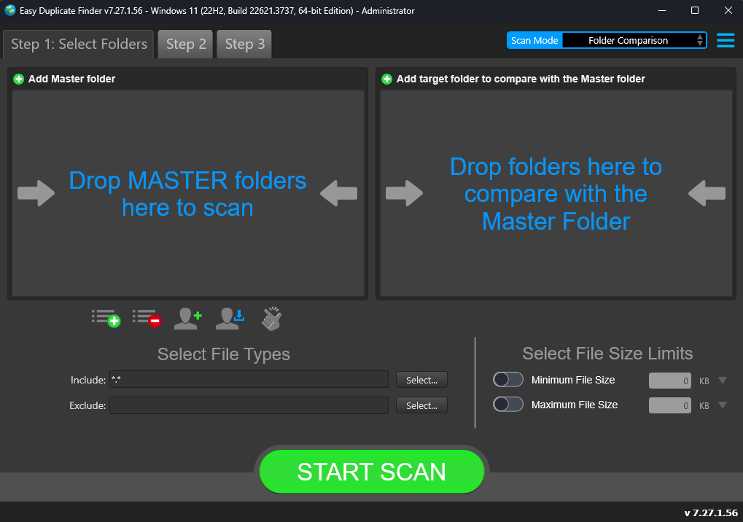

Figure – Performing a Folder Comparison Scan – EDF main screen

**Reference:** For more information, refer to **The Main Screen Description** section.

Below are the functions along with a description of the parameters that you can tweak before you start a Folder Comparison scan –

* + **MASTER folder (s) –** Clicking on the blue text on the left easel or by dragging a folder and dropping it in the area as depicted in the figure above, enables you to select a master folder which is to be compared against the target folder you specify in the right easel
  + **Target folder (s) –** Clicking on the blue text on the right easel or by dragging a folder and dropping it in the area as depicted in the figure above, enables you to select a target folder which is to be compared with the master folder specified in the left easel
  + **Import last scan –** Clicking this button opens a menu from which you can select this option to import the target folders of the last scan that you performed
  + **Import saved scan –** Clicking this button opens a menu from which you can select this option to import the target folders of the last scan that you performed and saved as a **.edfscan** file
  + **Import from Excel –** Clicking this button opens a menu from which you can select this option to import the target folders of the last scan that you performed and exported as an MS Excel file
  + **Clear List –** Clicking this button clears the target folder list

**Tip:** To clear the Exclude folder list perform a **Shift + Click** action

* + **Load settings profile:** Clicking this button enables you to load a scan profile settings that you saved as a **.edfsp** file
  + **Save settings profile:** Clicking this button enables you to save this scan profile settings as a **.edfsp** file
  + **Load the predefined “Easy Scan” profile:** Clicking this button enables you to load the predefined easy scan profile for this scan
  + **File Types –** Clicking the Select button in this area as depicted in the figure above enables you to specify which file types are to be scanned for duplicates and which are to be excluded
  + **File Size Limits –** Specifying the maximum & minimum file sizes enables you to specify the size range of the files to be scanned. Then you can specify the numerical values for both maximum & minimum limits and select the adjacent drop-downs to specify whether the limits must be considered in bytes (B), kilobytes (KB), megabytes (MB), or gigabytes (GB).

1. Click the blue text on the left easel or drag & drop a target folder that you intend to specify as a master folder in the left easel for this scan. Similarly, specify the target folder in the right easel to be compared with the specified master folder in the left easel. The specified folders are selected and listed as depicted in the figure below –

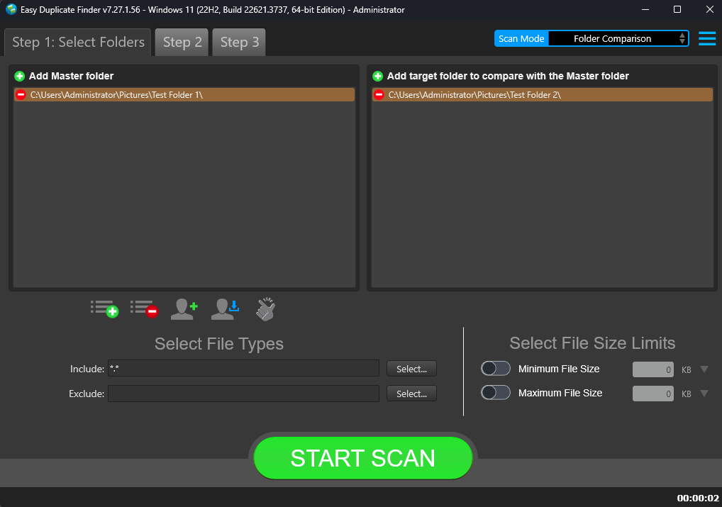

Figure – Selecting one or more folders

**Tip:** You can add more folders in the target folder list by clicking the green Add folders buttons as depicted in the figure above in both the Master & Target folder easels.

1. Specify the scan parameters as per your discretion and click **Start Scan**. Once the scan is finished, the scan results summary page is displayed as depicted in the figure below –

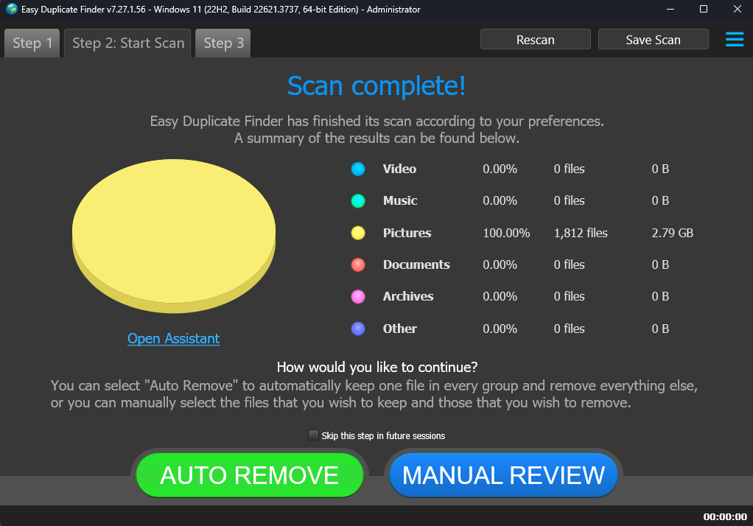

Figure – Scan results summary page

**Tip:** Clicking **AUTO REMOVE** will remove the identified duplicates automatically.

**Tip:** Clicking **Skip this step in future sessions** will not display this screen in future.

**Reference:** Clicking **Open Assistant** opens the Assistant wizard. For more information, refer to the **Using the Assistant on the Scan Summary Page** section.

1. Click **MANUAL REVIEW**. The scan result details page is displayed as depicted in the figure below –



Figure – Scan results details page

**Tip:** To preview the thumbnail of a selected file, click the **Preview** button provided on the top right-hand corner of this table.

**Tip:** You can also quickly view by their types by clicking their **File Type Links** provided just next to the Step 3 tab.

**Reference:** To save this scan, refer to **Saving a Scan** section. To import this scan later, refer to **Importing a Scan** section.

**Reference:** To perform multiple types of selections, refer to **Performing Multiple Types of Selections on the Scan Results page** section.

**Reference:** To export your scan results details as a file, refer to **Exporting your Scan Result Details as a File** section.

**Reference:** To clear the displayed scan results, refer to **Clearing the Displayed Scan Results from Scan Results page** section.

1. After you have selected the duplicate files that you intend to delete or move or in case you intend to replace the duplicate files with symbolic links or NTFS hard links, from the top right-hand corner on the scan results page, click the corresponding buttons as depicted in the figure below –



Figure – Scan Details Page Actions Menu

**Reference:** Refer to **Scan Detail Page Actions Menu Descriptions** section for a detailed description of the buttons available on the Scan Details Page Actions Menu.

The next chapter describes steps that enable you to **Perform a Google Drive Scan**.

# Performing a Google Drive Scan

While creating multiple albums / folder groupings, we may end up including the same photos / music / other files or their duplicates in multiple folder groups. In such a scenario often, we encounter duplicates which occupy storage space unnecessarily. Now it would make sense to remove such duplicates but a better resolution of such files would be to perform a folder comparison and link the duplicates as symbolic links or NTFS hard links. In this way we free up precious storage space and yet retain the file in the original folder and the symbolic link or NTFS hard link in the other folder.

The steps described below enable you to perform a Google Drive scan –

1. Navigate to the Easy Duplicate FinderTM application main screen as depicted in the figure below –



Figure – Performing a Google Drive Scan – EDF main screen

**Reference:** For more information, refer to **The Main Screen Description** section.

1. From the scan mode drop-down, select the Google Drive option. The Google Drive scan screen is displayed as depicted in the figure below –



Figure – Performing a Google Drive Scan – EDF main screen

**Reference:** For more information, refer to **The Main Screen Description** section.

Below are the functions along with a description of the parameters that you can tweak before you start a Google Drive scan –

* + **Include folder (s) –** Clicking on the blue INCLUDE text on the left easel or by dragging a folder and dropping it in the area as depicted in the figure above, enables you to select a target folder which is to be scanned
  + **Exclude folder (s) –** Clicking on the blue EXCLUDE text on the right easel or by dragging a folder and dropping it in the area as depicted in the figure above, enables you to select a target folder which is to be excluded from the scan
  + **Import last scan –** Clicking this button opens a menu from which you can select this option to import the target folders of the last scan that you performed
  + **Import saved scan –** Clicking this button opens a menu from which you can select this option to import the target folders of the last scan that you performed and saved as a **.edfscan** file
  + **Import from Excel –** Clicking this button opens a menu from which you can select this option to import the target folders of the last scan that you performed and exported as an MS Excel file
  + **Clear List –** Clicking this button clears the target folder list

**Tip:** To clear the Exclude folder list perform a **Shift + Click** action

* + **Load settings profile:** Clicking this button enables you to load a scan profile settings that you saved as a **.edfsp** file
  + **Save settings profile:** Clicking this button enables you to save this scan profile settings as a **.edfsp** file
  + **Load the predefined “Easy Scan” profile:** Clicking this button enables you to load the predefined easy scan profile for this scan
  + **File Types –** Clicking the Select button in this area as depicted in the figure above enables you to specify which file types are to be scanned for duplicates and which are to be excluded
  + **File Size Limits –** Specifying the maximum & minimum file sizes enables you to specify the size range of the files to be scanned. Then you can specify the numerical values for both maximum & minimum limits and select the adjacent drop-downs to specify whether the limits must be considered in bytes (B), kilobytes (KB), megabytes (MB), or gigabytes (GB).

1. Click the blue INCLUDE text on the left or drag & drop a target folder that you intend to scan. You may also specify folders to be excluded as per your requirements. The specified folder is selected and listed in target folder list as depicted in the figure below –



Figure – Selecting one or more folders

**Tip:** You can add more folders in the target folder list by clicking the green Add folders button as depicted in the figure above in both the INCLUDE & EXCLUDE easels.

1. Specify the scan parameters as per your discretion and click **Start Scan**. Once the scan is finished, the scan results summary page is displayed as depicted in the figure below –



Figure – Scan results summary page

**Tip:** Clicking **AUTO REMOVE** will remove the identified duplicates automatically.

**Tip:** Clicking **Skip this step in future sessions** will not display this screen in future.

**Reference:** Clicking **Open Assistant** opens the Assistant wizard. For more information, refer to the **Using the Assistant on the Scan Summary Page** section.

1. Click **MANUAL REVIEW**. The scan result details page is displayed as depicted in the figure below –



Figure – Scan results details page

**Tip:** To preview the thumbnail of a selected file, click the **Preview** button provided on the top right-hand corner of this table.

**Tip:** You can also quickly view by their types by clicking their **File Type Links** provided just next to the Step 3 tab.

**Reference:** To save this scan, refer to **Saving a Scan** section. To import this scan later, refer to **Importing a Scan** section.

**Reference:** To perform multiple types of selections, refer to **Performing Multiple Types of Selections on the Scan Results page** section.

**Reference:** To export your scan results details as a file, refer to **Exporting your Scan Result Details as a File** section.

**Reference:** To clear the displayed scan results, refer to **Clearing the Displayed Scan Results from Scan Results page** section.

1. After you have selected the duplicate files that you intend to delete or move or in case you intend to replace the duplicate files with symbolic links or NTFS hard links, from the top right-hand corner on the scan results page, click the corresponding buttons as depicted in the figure below –



Figure – Scan Details Page Actions Menu

**Reference:** Refer to **Scan Detail Page Actions Menu Descriptions** section for a detailed description of the buttons available on the Scan Details Page Actions Menu.

The next chapter describes steps that enable you to **Perform a Dropbox Scan**.

# Performing a Dropbox Scan

While creating multiple albums / folder groupings, we may end up including the same photos / music / other files or their duplicates in multiple folder groups. In such a scenario often, we encounter duplicates which occupy storage space unnecessarily. Now it would make sense to remove such duplicates but a better resolution of such files would be to perform a folder comparison and link the duplicates as symbolic links or NTFS hard links. In this way we free up precious storage space and yet retain the file in the original folder and the symbolic link or NTFS hard link in the other folder.

The steps described below enable you to perform a Dropbox scan –

1. Navigate to the Easy Duplicate FinderTM application main screen as depicted in the figure below –



Figure – Performing a Dropbox Scan – EDF main screen

**Reference:** For more information, refer to **The Main Screen Description** section.

1. From the scan mode drop-down, select the Dropbox Scan option. The Dropbox scan screen is displayed as depicted in the figure below –



Figure – Performing a Dropbox Scan – EDF main screen

**Reference:** For more information, refer to **The Main Screen Description** section.

Below are the functions along with a description of the parameters that you can tweak before you start a Dropbox scan –

* + **Include folder (s) –** Clicking on the blue INCLUDE text on the left easel or by dragging a folder and dropping it in the area as depicted in the figure above, enables you to select a target folder which is to be scanned
  + **Exclude folder (s) –** Clicking on the blue EXCLUDE text on the right easel or by dragging a folder and dropping it in the area as depicted in the figure above, enables you to select a target folder which is to be excluded from the scan
  + **Import last scan –** Clicking this button opens a menu from which you can select this option to import the target folders of the last scan that you performed
  + **Import saved scan –** Clicking this button opens a menu from which you can select this option to import the target folders of the last scan that you performed and saved as a **.edfscan** file
  + **Import from Excel –** Clicking this button opens a menu from which you can select this option to import the target folders of the last scan that you performed and exported as an MS Excel file
  + **Clear List –** Clicking this button clears the target folder list

**Tip:** To clear the Exclude folder list perform a **Shift + Click** action

* + **Load settings profile:** Clicking this button enables you to load a scan profile settings that you saved as a **.edfsp** file
  + **Save settings profile:** Clicking this button enables you to save this scan profile settings as a **.edfsp** file
  + **Load the predefined “Easy Scan” profile:** Clicking this button enables you to load the predefined easy scan profile for this scan
  + **File Types –** Clicking the Select button in this area as depicted in the figure above enables you to specify which file types are to be scanned for duplicates and which are to be excluded
  + **File Size Limits –** Specifying the maximum & minimum file sizes enables you to specify the size range of the files to be scanned. Then you can specify the numerical values for both maximum & minimum limits and select the adjacent drop-downs to specify whether the limits must be considered in bytes (B), kilobytes (KB), megabytes (MB), or gigabytes (GB).

1. Click the blue INCLUDE text on the left or drag & drop a target folder that you intend to scan. You may also specify folders to be excluded as per your requirements. The specified folder is selected and listed in target folder list as depicted in the figure below –



Figure – Selecting one or more folders

**Tip:** You can add more folders in the target folder list by clicking the green Add folders button as depicted in the figure above in both the INCLUDE & EXCLUDE easels.

1. Specify the scan parameters as per your discretion and click **Start Scan**. Once the scan is finished, the scan results summary page is displayed as depicted in the figure below –



Figure – Scan results summary page

**Tip:** Clicking **AUTO REMOVE** will remove the identified duplicates automatically.

**Tip:** Clicking **Skip this step in future sessions** will not display this screen in future.

**Reference:** Clicking **Open Assistant** opens the Assistant wizard. For more information, refer to the **Using the Assistant on the Scan Summary Page** section.

1. Click **MANUAL REVIEW**. The scan result details page is displayed as depicted in the figure below –



Figure – Scan results details page

**Tip:** To preview the thumbnail of a selected file, click the **Preview** button provided on the top right-hand corner of this table.

**Tip:** You can also quickly view by their types by clicking their **File Type Links** provided just next to the Step 3 tab.

**Reference:** To save this scan, refer to **Saving a Scan** section. To import this scan later, refer to **Importing a Scan** section.

**Reference:** To perform multiple types of selections, refer to **Performing Multiple Types of Selections on the Scan Results page** section.

**Reference:** To export your scan results details as a file, refer to **Exporting your Scan Result Details as a File** section.

**Reference:** To clear the displayed scan results, refer to **Clearing the Displayed Scan Results from Scan Results page** section.

1. After you have selected the duplicate files that you intend to delete or move or in case you intend to replace the duplicate files with symbolic links or NTFS hard links, from the top right-hand corner on the scan results page, click the corresponding buttons as depicted in the figure below –



Figure – Scan Details Page Actions Menu

**Reference:** Refer to **Scan Detail Page Actions Menu Descriptions** section for a detailed description of the buttons available on the Scan Details Page Actions Menu.

The next chapter describes steps that enable you to **Perform an Empty Folders Scan**.

# Performing an Empty Folders Scan

While creating multiple albums / folder groupings, we may end up including the same photos / music / other files or their duplicates in multiple folder groups. In such a scenario often, we encounter duplicates which occupy storage space unnecessarily. Now it would make sense to remove such duplicates but a better resolution of such files would be to perform a folder comparison and link the duplicates as symbolic links or NTFS hard links. In this way we free up precious storage space and yet retain the file in the original folder and the symbolic link or NTFS hard link in the other folder.

The steps described below enable you to perform an Empty Folders scan –

1. Navigate to the Easy Duplicate FinderTM application main screen as depicted in the figure below –



Figure – Performing a Empty Folders Scan – EDF main screen

**Reference:** For more information, refer to **The Main Screen Description** section.

1. From the scan mode drop-down, select the Empty Folders option. The Empty Folders scan screen is displayed as depicted in the figure below –



Figure – Performing a Empty Folders Scan – EDF main screen

**Reference:** For more information, refer to **The Main Screen Description** section.

Below are the functions along with a description of the parameters that you can tweak before you start a Empty Folders scan –

* + **Include folder (s) –** Clicking on the blue INCLUDE text on the left easel or by dragging a folder and dropping it in the area as depicted in the figure above, enables you to select a target folder which is to be scanned
  + **Exclude folder (s) –** Clicking on the blue EXCLUDE text on the right easel or by dragging a folder and dropping it in the area as depicted in the figure above, enables you to select a target folder which is to be excluded from the scan
  + **Import last scan –** Clicking this button opens a menu from which you can select this option to import the target folders of the last scan that you performed
  + **Import saved scan –** Clicking this button opens a menu from which you can select this option to import the target folders of the last scan that you performed and saved as a **.edfscan** file
  + **Import from Excel –** Clicking this button opens a menu from which you can select this option to import the target folders of the last scan that you performed and exported as an MS Excel file
  + **Clear List –** Clicking this button clears the target folder list

**Tip:** To clear the Exclude folder list perform a **Shift + Click** action

* + **Load settings profile:** Clicking this button enables you to load a scan profile settings that you saved as a **.edfsp** file
  + **Save settings profile:** Clicking this button enables you to save this scan profile settings as a **.edfsp** file
  + **Load the predefined “Easy Scan” profile:** Clicking this button enables you to load the predefined easy scan profile for this scan
  + **File Types –** Clicking the Select button in this area as depicted in the figure above enables you to specify which file types are to be scanned for duplicates and which are to be excluded
  + **File Size Limits –** Specifying the maximum & minimum file sizes enables you to specify the size range of the files to be scanned. Then you can specify the numerical values for both maximum & minimum limits and select the adjacent drop-downs to specify whether the limits must be considered in bytes (B), kilobytes (KB), megabytes (MB), or gigabytes (GB).

1. Click the blue INCLUDE text on the left or drag & drop a target folder that you intend to scan. You may also specify folders to be excluded as per your requirements. The specified folder is selected and listed in target folder list as depicted in the figure below –



Figure – Selecting one or more folders

**Tip:** You can add more folders in the target folder list by clicking the green Add folders button as depicted in the figure above in both the INCLUDE & EXCLUDE easels.

1. Specify the scan parameters as per your discretion and click **Start Scan**. Once the scan is finished, the scan results summary page is displayed as depicted in the figure below –



Figure – Scan results summary page

**Tip:** Clicking **AUTO REMOVE** will remove the identified duplicates automatically.

**Tip:** Clicking **Skip this step in future sessions** will not display this screen in future.

**Reference:** Clicking **Open Assistant** opens the Assistant wizard. For more information, refer to the **Using the Assistant on the Scan Summary Page** section.

1. Click **MANUAL REVIEW**. The scan result details page is displayed as depicted in the figure below –



Figure – Scan results details page

**Tip:** To preview the thumbnail of a selected file, click the **Preview** button provided on the top right-hand corner of this table.

**Tip:** You can also quickly view by their types by clicking their **File Type Links** provided just next to the Step 3 tab.

**Reference:** To save this scan, refer to **Saving a Scan** section. To import this scan later, refer to **Importing a Scan** section.

**Reference:** To perform multiple types of selections, refer to **Performing Multiple Types of Selections on the Scan Results page** section.

**Reference:** To export your scan results details as a file, refer to **Exporting your Scan Result Details as a File** section.

**Reference:** To clear the displayed scan results, refer to **Clearing the Displayed Scan Results from Scan Results page** section.

1. After you have selected the duplicate files that you intend to delete or move or in case you intend to replace the duplicate files with symbolic links or NTFS hard links, from the top right-hand corner on the scan results page, click the corresponding buttons as depicted in the figure below –



Figure – Scan Details Page Actions Menu

**Reference:** Refer to **Scan Detail Page Actions Menu Descriptions** section for a detailed description of the buttons available on the Scan Details Page Actions Menu.

The next chapter describes steps that enable you to **Perform a OneDrive Scan**.

# Performing a OneDrive Scan

While creating multiple albums / folder groupings, we may end up including the same photos / music / other files or their duplicates in multiple folder groups. In such a scenario often, we encounter duplicates which occupy storage space unnecessarily. Now it would make sense to remove such duplicates but a better resolution of such files would be to perform a folder comparison and link the duplicates as symbolic links or NTFS hard links. In this way we free up precious storage space and yet retain the file in the original folder and the symbolic link or NTFS hard link in the other folder.

The steps described below enable you to perform a OneDrive scan –

1. Navigate to the Easy Duplicate FinderTM application main screen as depicted in the figure below –



Figure – Performing a OneDrive Scan – EDF main screen

**Reference:** For more information, refer to **The Main Screen Description** section.

1. From the scan mode drop-down, select the OneDrive Scan option. The OneDrive scan screen is displayed as depicted in the figure below –



Figure – Performing a OneDrive Scan – EDF main screen

**Reference:** For more information, refer to **The Main Screen Description** section.

Below are the functions along with a description of the parameters that you can tweak before you start a OneDrive scan –

* + **Include folder (s) –** Clicking on the blue INCLUDE text on the left easel or by dragging a folder and dropping it in the area as depicted in the figure above, enables you to select a target folder which is to be scanned
  + **Exclude folder (s) –** Clicking on the blue EXCLUDE text on the right easel or by dragging a folder and dropping it in the area as depicted in the figure above, enables you to select a target folder which is to be excluded from the scan
  + **Import last scan –** Clicking this button opens a menu from which you can select this option to import the target folders of the last scan that you performed
  + **Import saved scan –** Clicking this button opens a menu from which you can select this option to import the target folders of the last scan that you performed and saved as a **.edfscan** file
  + **Import from Excel –** Clicking this button opens a menu from which you can select this option to import the target folders of the last scan that you performed and exported as an MS Excel file
  + **Clear List –** Clicking this button clears the target folder list

**Tip:** To clear the Exclude folder list perform a **Shift + Click** action

* + **Load settings profile:** Clicking this button enables you to load a scan profile settings that you saved as a **.edfsp** file
  + **Save settings profile:** Clicking this button enables you to save this scan profile settings as a **.edfsp** file
  + **Load the predefined “Easy Scan” profile:** Clicking this button enables you to load the predefined easy scan profile for this scan
  + **File Types –** Clicking the Select button in this area as depicted in the figure above enables you to specify which file types are to be scanned for duplicates and which are to be excluded
  + **File Size Limits –** Specifying the maximum & minimum file sizes enables you to specify the size range of the files to be scanned. Then you can specify the numerical values for both maximum & minimum limits and select the adjacent drop-downs to specify whether the limits must be considered in bytes (B), kilobytes (KB), megabytes (MB), or gigabytes (GB).

1. Click the blue INCLUDE text on the left or drag & drop a target folder that you intend to scan. You may also specify folders to be excluded as per your requirements. The specified folder is selected and listed in target folder list as depicted in the figure below –



Figure – Selecting one or more folders

**Tip:** You can add more folders in the target folder list by clicking the green Add folders button as depicted in the figure above in both the INCLUDE & EXCLUDE easels.

1. Specify the scan parameters as per your discretion and click **Start Scan**. Once the scan is finished, the scan results summary page is displayed as depicted in the figure below –



Figure – Scan results summary page

**Tip:** Clicking **AUTO REMOVE** will remove the identified duplicates automatically.

**Tip:** Clicking **Skip this step in future sessions** will not display this screen in future.

**Reference:** Clicking **Open Assistant** opens the Assistant wizard. For more information, refer to the **Using the Assistant on the Scan Summary Page** section.

1. Click **MANUAL REVIEW**. The scan result details page is displayed as depicted in the figure below –



Figure – Scan results details page

**Tip:** To preview the thumbnail of a selected file, click the **Preview** button provided on the top right-hand corner of this table.

**Tip:** You can also quickly view by their types by clicking their **File Type Links** provided just next to the Step 3 tab.

**Reference:** To save this scan, refer to **Saving a Scan** section. To import this scan later, refer to **Importing a Scan** section.

**Reference:** To perform multiple types of selections, refer to **Performing Multiple Types of Selections on the Scan Results page** section.

**Reference:** To export your scan results details as a file, refer to **Exporting your Scan Result Details as a File** section.

**Reference:** To clear the displayed scan results, refer to **Clearing the Displayed Scan Results from Scan Results page** section.

1. After you have selected the duplicate files that you intend to delete or move or in case you intend to replace the duplicate files with symbolic links or NTFS hard links, from the top right-hand corner on the scan results page, click the corresponding buttons as depicted in the figure below –



Figure – Scan Details Page Actions Menu

**Reference:** Refer to **Scan Detail Page Actions Menu Descriptions** section for a detailed description of the buttons available on the Scan Details Page Actions Menu.

The next section of this user manual **Frequently Asked Questions (FAQs)** as an appendix.

1. Frequently Asked Questions (FAQs)

Here is a list of frequently asked questions with reference to the Easy Duplicate FinderTM application and its usage –

Why do I need Easy Duplicate Finder™?

Easy Duplicate FinderTM is the app that makes it easy to move all your files, user profiles, settings, software and even drivers from one computer to another. It's perfect for configuring a new computer with all your stuff, syncing folders, and keeping data and settings the same on two or more computers.

1. How do I install Easy Duplicate FinderTM on a Windows PC?

**Tip:** Refer to Downloading the EDF Application Installer section

I have folders with intentional copies of my photos that I use as backups. How can I exclude them from EDF's scans?

You'll need to add these folders to the Ignore List. To do that, go to Settings, click on the Ignore List tab, and add the folders you want to exclude from scans.

What are the trial version limitations?

The trial version of Easy Duplicate FinderTM offers unlimited scanning for duplicates images. You can then delete up to 10 duplicate groups with the trial version.

I thought I had purchased a license for 3 computers, but it looks like I've purchased a single-PC license. Is there any way to upgrade my license for the price difference between the two?

Please log into your account from [this](https://www.duplicatephotocleaner.com/login) page. To the right of your license key, you'll see two links – to renew and to upgrade. Click on the Upgrade button and follow the prompts.

I want to install Easy Duplicate FinderTM on another computer using my current license key. Is that possible?

If you ever need to reinstall Easy Duplicate FinderTM or move it to a different computer, you should copy your license key and unregister the program before you do anything else. To do that click on "Help" and go to the "About" screen inside the program. Then make a note of your license key and remove the key. This will reset the license so that you can reactivate it on a new installation (this feature is limited to 3 times).

**Note:** if your license key has expired, please visit the Version History page on the site and download the version that was released before your key expired. An expired key will not activate any version released after the key's expiration.

**Tip:** For more information, refer to Purchasing your and Removing your EDF License Details chapters.

My computer is not connected to the Internet. Is there a way to activate Easy Duplicate FinderTM offline?

Follow these steps to activate Easy Duplicate FinderTM on a computer that's not connected to the Internet:

1. Purchase a license key and install Easy Duplicate FinderTM on your computer.
2. Open Easy Duplicate FinderTM, click on Help in the menu and go to "About".
3. Copy the product key from the popup that appears.
4. Go to [this](https://www.duplicatephotocleaner.com/support) page and open a support ticket. Make sure you send both your product key and your license key to the Support Team.
5. Our Support Team will generate activation data for your copy of Easy Duplicate FinderTM and email it to you.
6. Copy the activation data from the email, save it as a text file and put the file on a flash drive.
7. Connect the flash drive to your offline computer, open the text file with the activation data, select all of it and copy it. Important: don't paste it anywhere at this point!
8. Open Easy Duplicate FinderTM. If you have valid activation data and if you've followed these steps correctly, your copy of Easy Duplicate FinderTM will become activated.

If you're on Windows, you can ask the Support Team to email you a Master File that you can save to the folder where Easy Duplicate FinderTM is installed. Then simply open Easy Duplicate FinderTM and it will get activated.

I'm updating to Windows 10. Will your software continue to work?

We've become aware of a Easy Duplicate FinderTM registration glitch that some people experience when they update to Windows 10. We've investigated the problem and found a solution. So, if you are planning to update to Windows 10, please follow these steps before you run the update:

1. Open Easy Duplicate FinderTM and click on "About" in the top right corner
2. Make a note of your registration code, then select "Remove key" and close the program
3. Update your operating system to Windows 10
4. Open Easy Duplicate FinderTM again and click on the "Register Now" button
5. Close the Web page that opens (you don't need that page because you already have your license code)
6. Enter your license code and the e-mail address you used to register in a pop-up window that appears
7. Click "Activate" and continue to enjoy Easy Duplicate FinderTM

What formats does Easy Duplicate FinderTM support?

Easy Duplicate Finder supports BMP, JPG, JPEG, JFIF, PNG, TIF, TIFF, GIF, ICO, WMP, ICNS, PSD, TGA, RAW, CRW, CR2, CR3, NEF, PEF, RAF, X3F, BAY, ORF, SRF, MRW, DCR, SR2, DNG, RW2, ARW, HEIC, HEIF, 3FR, DCX, DIB, EMF, JPS, HDP, PBM, PGM, PNS, PPM, PCT, CUR, WEBP, BAY, ERF, KDC, RWL, MEF, NRW, PTX, SRW, RLE, DDS, WDP, JXR, HDP, JPE, JIF, J2K, JPC, J2C, JP2, PCX, SVG, DCM, DIC, DICOM and V2.

How can I get more information about the images?

Setting the scan results view to tree view will make the program display information like image width and height, size, and modification date in addition to image location. To change your view settings to tree view, click on the View result menu item and select as Tree.

I want to scan for duplicate JPG images only. How can I prevent the program from detecting GIF, BMP and PNG files?

Simply go to program settings, navigate to the File Search tab, and uncheck BMP, GIF and PNG. Click OK to save your settings.

What is the benefit of comparing photos in grayscale?

Comparing photos in grayscale will help you get more matches without lowering the image similarity threshold. When you search for duplicate and similar photos in grayscale as opposed to in full color, Easy Duplicate FinderTM disregards color changes. This method allows you to find more duplicates and more similar images you may want to move or delete.

To compare photos in grayscale, go to Easy Duplicate FinderTM settings and check "Use grayscale comparison" on the File Search tab.

What is Sector Detail Scan and how does it work?

Sector Detail Scan is a scan mode introduced in Easy Duplicate FinderTM 2.8. This mode lets you select a sector on an image and search other images for that specific sector. Here is how to use it:

1. Select "Sector Detail Scan" as your scan mode
2. Select the folders you want to scan for similar images
3. Add a photo and select a sector on it that you want to find in other images
4. Start the scan

Because Sector Detail Scan is very precise, it can take several hours to complete the scan. To make your scans faster, we suggest that you set the similarity threshold to 50% and scan smaller folders.

What is the difference between Easy Duplicate Finder™ and Easy Duplicate FinderTM?

Both [Easy Duplicate Finder](https://www.easyduplicatefinder.com/)™ and Easy Duplicate FinderTM are designed to find and delete duplicate files. The main difference between these two apps is that Easy Duplicate Finder™ works with duplicates of all file types, whereas Easy Duplicate FinderTM works with images only. In addition to that, Easy Duplicate Finder™ can only find exact duplicates. Easy Duplicate Finder is different because it can detect both identical and similar images, such as resized and edited photos. It can also find photos in different formats (a .JPG file vs. a .PNG file, for example).

If you are having trouble choosing between Easy Duplicate Finder™ and Easy Duplicate FinderTM, ask yourself what types of duplicates you want to find. Easy Duplicate Finder™ is ideal if you want to delete duplicate documents, songs, photos, emails, and videos from your computer. But if all you want to do is organize your extensive image library, consider getting Easy Duplicate FinderTM. It will not only help you find and delete duplicates, but also let you easily sort through similar shots and decide which ones to keep and which to delete or move.

How can I select multiple images when the scan is complete?

You can select images you want to delete in bulk on the Scan Results screen. Use the "Select Photos" drop-down menu to select all duplicates, select all originals, or select only high or low-resolution images.

How can I delete multiple files in Easy Duplicate FinderTM?

To delete several files in one go, select the files you want to delete and then click on the trash can icon in the top right corner of the app screen.

I have a really large photo library. What's the best way to manage it with Easy Duplicate FinderTM?

If you have a very large photo library, follow these steps to make deleting duplicate and similar photos as efficient as possible:

1. Go to Easy Duplicate FinderTM settings and set the similarity threshold to 100%, then scan your whole photo library. This will allow you to find exact duplicates and delete them in a single click.
2. When your photo collection is free from exact duplicates, go back to the Settings panel and set the similarity threshold to 85%.
3. Break up your photo library into several manageable parts, scan it part by part, and resolve similar images in each part.
4. When done, scan your whole photo library once again to find any duplicates and similar photos you might have missed.

Is there a way to compare images in folder A against images in folder B with Easy Duplicate FinderTM?

Simply go to the Scan Mode drop-down menu and choose Folder Comparison. Then add a source folder to the left drag & drop area and Easy Duplicate FinderTM will treat files in this folder as the originals. Then add the folders you want to compare against the source folder to the target scan area to the right and run a scan. When done, use Easy Duplicate FinderTM to delete the duplicates as you normally would.

What exactly does the Folder Comparison scan mode do?

The Folder Comparison mode is a special scan mode that makes it easy to compare images in two or more folders. It treats files in Source Folders as originals (master files), thus helping you to avoid any confusion when you're choosing which photos to delete and which to keep. This mode is great for comparing files on external drives with images on your computer and merging folders.

How does Easy Duplicate FinderTM decide which photos are the originals and which are the duplicates?

When you are using most scan modes, Easy Duplicate FinderTM considers the first image in a group of duplicates the original file.

When you switch to the Folder Comparison mode, all the files in the Source Folder(s) are treated as the originals, while the photos in target folders are marked as the duplicates.

In Sector Detail Scan mode, the source image file is the original.

What is multi-threaded image processing?

This feature makes Easy Duplicate FinderTM use all available CPU cores for image processing. Enabling this feature makes the scan up to 50% faster.

How does Easy Duplicate FinderTM? Does it simply compare Meta (EXIF) data or does it compare the actual images?

Easy Duplicate FinderTM uses an advanced algorithm to compare the actual images, just like a human would. Depending on the program settings, it may take EXIF data into account when determining image similarity level.

Which versions of Adobe Lightroom are supported?

Easy Duplicate FinderTM supports Adobe Lightroom 6 and newer. If you have an older version on your computer, the Lightroom Scan mode will not appear in the Scan Modes menu.

How to use the Search / Filter results feature in EDF?

The Search / Filter results feature offers you a handy way to go through the scan results and manage your photos more effectively. You can open the Search / Filter window by clicking on the "Search" icon in the top right corner of the results window.



Figure : Opening the Search / Filter window

The search tool lets you search / filter files by name, by date, by size, and by duplicate group.

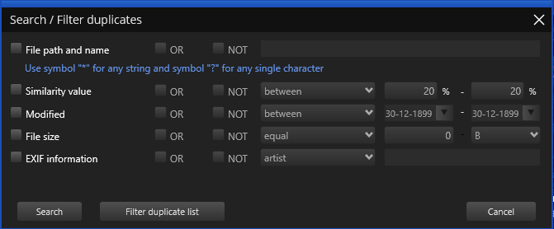

Figure : Search / Filter window

The file name field allows you to use wildcard characters where an asterisk (*) represents one or more characters and the question mark (?) represents a single character.

The asterisk in a wildcard matches any character that appears zero or more times. For example, "comp*" matches anything beginning with "comp" which means "comp," "complete," and "computer" are all matched.

The question mark stands for a single character mentioned only once. For example, "c?mp" could be either "camp" or "comp".

You can use this feature and wildcard characters to search EDF scan results quickly and effectively to find the images you need.

How do I save a scan and import it later?

**Reference:** To Save a scan , refer to **Saving a Scan** section.

**Reference:** To Import a saved scan , refer to **Importing a Scan** section.

Can I use Easy Duplicate FinderTM to delete duplicates from my smartphone?

Yes, you can! Simply connect your phone to your Windows PC and open Easy Duplicate FinderTM. It will automatically detect a connected phone and offer to scan it for duplicate and similar photos. Alternatively, open EDF, select Media Device Scan from the scan modes drop-down menu and connect your phone. Your phone may ask you to give Easy Duplicate FinderTM the necessary permissions (check your phone for notifications). When done, follow EDF's prompts to scan your phone.

Does Easy Duplicate FinderTM support Android and iOS devices?

You can use EDF to scan your iOS and Android devices for duplicate and similar photos by connecting your phone to your Windows PC and using EDF's Media Device Scan mode.

Do I have to add all the folders with photos when using the Media Device Scan mode?

No, you don't need to add folders one by one. Easy Duplicate FinderTM uses the Media Transfer Protocol to scan photos on your smartphone, which means that all you need to do is connect your phone and EDF will detect and scan all the photos on the device.

How does Easy Duplicate FinderTM determine which image is the original and which is the duplicate?

EDF sees an image as the original based on a set of conditions. Here they are in order of priority:

* the file has the largest resolution in the group
* the file has the largest size in the group
* the file is the "newest" in the group (determined by modification date)

My scan got stuck! What to do?

If your scan with Easy Duplicate FinderTM got stuck or is very slow, don't panic because most likely it's not a bug. This could be happening because you've chosen a very accurate scan mode and added too many images for Easy Duplicate FinderTM to compare. Just stop your current scan and try the following:

* Add smaller folders - don't scan your entire image library in one go
* If you are using Sector Detail Scan, lower the similarity threshold to 50% and never add large folders
* Eliminate true duplicates first - select Standard Scan and set the similarity threshold to 100%, delete the duplicates and then start looking for similar images in smaller chunks

This will help you speed up Easy Duplicate FinderTM scans and manage your photos more effectively.

My Windows computer won't let me install Easy Duplicate FinderTM. What to do?

Most likely, your computer needs you to run the installer as Administrator. Here is how you can do that:

1. Right-click on the duplicatephotocleanersetup.exe setup file
2. Select "Run as Administrator..."
3. Follow the setup instructions

I accidentally closed Easy Duplicate FinderTM. Is there a way for me to load previous scan results?

Easy Duplicate FinderTM doesn't save your scan progress automatically but it offers you an option to pause and resume scans. If you've paused a scan, EDF will resume it right where it left off even if you've closed the application.

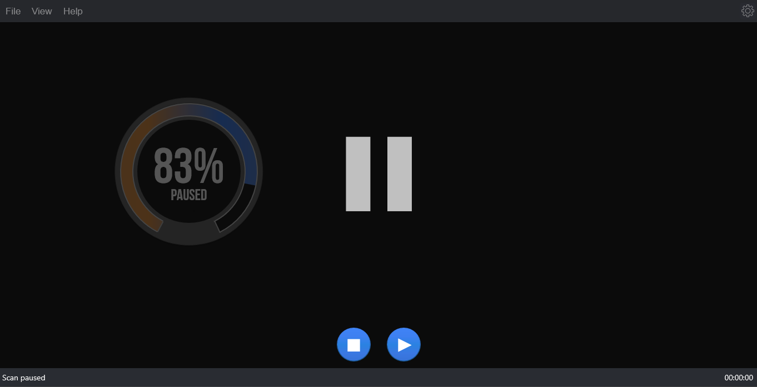

Figure : Pausing a scan

We recommend that you use the Pause feature if you decide to abort a scan because you don't have the time to sort through the results. This will speed things up a great deal.

My system crashed and Easy Duplicate FinderTM got unregistered. How do I get my software up and running again?

First, go to www.duplicatephotocleaner.com, download the .exe (Windows) or .dmg (Mac) installation file depending upon your operating system and install Easy Duplicate FinderTM. If you have a license key, you can log into your account with the email address used when you purchased your license key from [this](https://www.duplicatephotocleaner.com/login) page. There you will see your current license key. You can also find your license key in the email we sent you when you purchased Easy Duplicate FinderTM. Use the key to activate Easy Duplicate FinderTM by running the program and entering the license key in the activation box.

If you discover that your license key has expired, make sure you go to the "[Version History](https://www.duplicatephotocleaner.com/history)" page and install an older version, the one for which you bought the key. Easy Duplicate FinderTM will work as it should, although you won't be able to download updates. Your key should activate any version released prior to your software expiring.

If you lost your license key, please submit a [support ticket](https://www.duplicatephotocleaner.com/ticket) and send us all the relevant information about your purchase.

I have a drive that has only photos on it. After about 15 minutes of scanning, the program hangs.

Easy Duplicate FinderTM supports large amounts of files and works on large drives. Please make sure your drive is not damaged and doesn't have bad sectors. Also please make sure you have the latest version of Easy Duplicate FinderTM installed. You can check for new versions by opening the program, clicking on Help in the menu and clicking on Update.

Easy Duplicate FinderTM reported that some duplicate files could not be deleted. Why is that and how can I fix this?

There could be several reasons why Easy Duplicate FinderTM is not deleting these files. Here are the most common fixes for this problem:

1. Make sure you are using Easy Duplicate FinderTM as administrator. To do that, close the program, right-click on its shortcut on your desktop and select "Run as administrator" from the right-click menu.
2. The files you are trying to delete are being used by another application. Close all programs except Easy Duplicate FinderTM and try deleting the duplicates again.
3. UAC (User Access Control) is preventing you from deleting the files. Try disabling UAC or editing its sensitivity from the Control Panel, then try deleting the files again.
4. Make sure the files you're trying to delete aren't located on a read-only drive, like a CD or a DVD.

I still use Windows XP on my computer. Is Easy Duplicate FinderTM compatible with it?

Yes, Easy Duplicate FinderTM is compatible with Windows XP even though it's designed to work on the newest operating systems to ensure highly accurate results and great performance. However, Windows XP is an outdated OS and even Microsoft stopped supporting it. That's why some users may experience problems using the latest versions of Easy Duplicate FinderTM on XP. If that's the case with you, we suggest you download the following version:

[Download Easy Duplicate Finder v. 2.4.0.142](https://www.duplicatephotocleaner.com/files/2.4.0.142/dpcSetup.exe)

I use Windows tags to organize my photos and I want to delete images that don't have them. Can EDF help?

Absolutely! Easy Duplicate FinderTM supports Windows tags. Simply scan your image library and wait for the results to be displayed. You can hover over image thumbnails in Multiviewer to view EXIF data and Windows tags. When you are ready to select the images based on Windows tags, use the "Select files with tags" and "Select files without tags" bulk selection options.

Can I launch Easy Duplicate FinderTM to scan a specific folder when I'm browsing my computer?

Yes. Easy Duplicate FinderTM supports Windows context menu, so all you need to do is right-click on a folder you want to scan and select Easy Duplicate FinderTM.

After the search is complete, I click "Select files with the original names" and no files are selected in some duplicate groups. Why is that?

This means that EDF couldn't identify the original for these groups. When EDF cannot determine the original file in the group because all files match the same criteria (i.e., have the same file name), it will not select any files in the group. You can still use bulk selection options that use different criteria.

When I click "Reverse selection", both files in groups where the bulk selections didn't work become selected.

That's because the "Reverse selection" option changes the selection to the opposite state (selected -> non-selected, non-selected -> selected)

The next section of this user manual includes an **Index** of frequently referred terms or phrases with reference to the Easy Duplicate FinderTM application and its usage.

Index

A

Abbreviations / Acronyms used in this User Manual v

About this User Manual iii

Activating your DPC Installation 65

C

Clearing the Displayed Scan Results from Scan Results page 55

D

Deleting selected files 48

Downloading the DPC Application Installer 11

E

Entering a New Key 70

Exporting your Scan Result Details as a File 49

F

Frequently Asked Questions (FAQs) 146

G

Getting Started 12

Getting the Premium Free Trial 59

I

Importing a Scan 37

In Scope of this User Manual iii

Intended Audience of this User Manual iii

Introduction 11

L

Limitations of Utilizing an Unregistered DPC Application in Trial Mode 34

M

Moving selected files to a specific folder 44

O

Organization of this User Manual iii

Out of Scope of this User Manual iii

P

Performing a Byte-By-Byte Comparison Scan 82

Performing a Dropbox Scan 124

Performing a Filename Only Scan 89

Performing a Folder Comparison Scan 110

Performing a Google Drive Scan 117

Performing a Music Scan 96

Performing a OneDrive Scan 138

Performing a Search / Filter Duplicates Action 41

Performing a SHA256 Checksum + FileSize Scan 76

Performing an Empty Folders Scan 131

Performing an Outlook Mail Scan 103

Performing an Undo Action 57

Performing General Functions during all Scan Types 35

Performing Multiple Types of Selections on the Scan Results page 42

Purchasing your License Key 64

Purpose of this User Manual iii

R

Removing resolved files from the results 56

Removing your DPC License Details 73

Renaming selected files 47

Replacing selected files with NTFS hard links 46

Replacing selected files with symlinks 45

S

Saving a Scan 35

Saving a scan from the Scan Details page 36

Saving a scan from the Scan Summary page 35

Saving your scan 54

Scan Detail Page Actions Menu Descriptions 39

T

Terms Used in this User Manual v

The About Option Detailed Description 31

The Clear File Information Cache Detailed Description 32

The Email Scan tab 22

The File/Folder Synchronization Detailed Description 30

The General tab 16

The Hamburger Menu Options Descriptions 14

The Ignore List tab 25

The Logging tab 24

The Main Screen Description 13

The Music Scan tab 21

The Open Wizard Option Detailed Description 33

The Register Now Option Detailed Description 32

The Scan Settings tab 18

The Settings Panel Detailed Description 16

The SHA256 Calculator Detailed Description 28

The Sounds tab 26

The Support tab 27

The Update Option Detailed Description 31

The Windows DriverStore Cleaner Detailed Description 29

Typographical Conventions / Customaries used in this User Manual iv

U

Using the Assistant on the Scan Summary Page 38

V

Via the Activate buttons & link 65

Via the Free Trial buttons & link 59

Via the Register Now Button in the DPC Application Menu 61, 67

Viewing Files based on their File Type 40

Viewing the File Contents Preview 40

W

Why do I need Duplicate Photo Cleaner™? 146